Case No. OGRA-6(2)-2(6)/2007

IN THE MATTER OF

SUI SOUTHERN GAS COMPANY LIMITED
ESTIMATED REVENUE REQUIREMENT, FY 2008-09

UNDER

SECTION 8 (1) OF THE OIL AND GAS REGULATORY
AUTHORITY ORDINANCE, 2002 AND
RULE 4 (2) OF NATURAL GAS TARIFF RULES, 2002

DECISION

May 20, 2008

Before:
Munir Ahmad (Chairman)
Rashid Farooq, Member (Oil) / Vice Chairman
M.H. Asif, Member (Finance)
Syed Hadi Hasnain, Member (Gas)
TABLE OF CONTENTS

1. Background 1
2. Salient Features of the Petition 3
3. Hearing 6
a) General Comments 7
b) Industrial Consumers -Specific Comments 8
c) CNG Industry-Specific Comment 10
d) Shareholders-Representatives Comments 11
4. Authority’s Jurisdiction and Determination Process 11
5. Return to Licensee 14
6. Operating Fixed Assets 15
6.1. Summary 15
6.2. Transmission 18
i) Summary 18
6.3. Distribution Development 18
i) Summary 18
ii) Land 19
iii) Road, Pavements and Related (Right of way - ROW) 19
iv) Building 20
v) Plant & Machinery 20
vi) Furniture, Equipment including Computers & Allied Equipment 21
vii) Appliances, Loose Tools & Equipment 21
viii) Telecommunication System 22
ix) Construction Equipment & Vehicles 22
x) Remaining Assets 23
6.4. IT Related Expenditure 23
6.5. Fixed Assets Determined by the Authority 24
7. Operating Revenues 25
7.1. Sales Volume 25
7.2. Sales Revenue at Existing Prescribed Prices 26
7.3. Other Operating Income 26
i. Summary 26
ii. Revenue from JJVL 27
iii. Amortization of Deferred Credit 28
iv. Other Income 28
7.4. Air-Mix LPG Project 29
8. Operating Expenses 31
8.1. Cost of Gas 31
8.2. Unaccounted for Gas (UFG) 32
8.3. Transmission and Distribution Cost 36
i. Summary 36
ii. Human Resource (HR) Cost 36
iii. Insurance 37
iv. Advertisement 38
v. Repair & Maintenance 38
vi. Legal & Professional Charges 39
vii. Provision for Doubtful Debts 40
viii. Inter State Gas Systems (Pvt.) Limited (ISGSL) 40
ix. Expenditure Relating to LNG Project 43
x. Gas Internally Consumed 43
xi. Loss Due to Sabotage Activity 44
xii. Remaining Items of Transmission and Distribution Cost 44
xiii. Transmission and Distribution Cost Determined by the Authority 45
8.4. Government Grants 46
8.5. Other Charges including Workers Profit Participation Fund (WPPF) 47
9. Decision 47
10. Directions 50
11. Public Critique, Views, Concerns, Suggestions 51

ANNEXURES

A: Computation of Estimated Revenue Requirement for FY 2008-09 52
B: Provisional Prescribed Prices for FY 2008-09 w.e.f. July 1, 2008 53
C: Comparison between Existing Sale Prices and Revised Prescribed Prices 55
D: Detail of Addition to Rate Base Requested by the Petitioner for FY 2008-09 56
E: Computation of Weighted Average Cost of Gas 57

TABLES

Table 1: Comparison of Projected Cost of Service with Previous Years 2
Table 2: Comparison of Projected Operating Revenues with Previous Years 4
Table 3: Comparison of Projected Operating Expenses with Previous Years 5
Table 4: Computation of Requested Average Increase in Prescribed Price 6
Table 5: Computation of Projected Return according to the Petition on Operating Fixed Assets 15
Table 6: Comparison of Projected Deferred Credits with RERR-II FY 2007-08 16
Table 7: Computation of Deferred Credits Determined by the Authority 16
Table 8: Summarized Schedule of Projected Additions Compared with Previous Years 17
Table 9: Additions to Transmission Network Provisionally Allowed as Requested 18
Table 10: Detail of Additions to Distribution Network 19
Table 11: Historical Analysis of Land 19
Table 12: ROW Allowed by the Authority 20
Table 13: Historical Analysis of Building 20
Table 14: Capitalization trend of Plant & Machinery 21
Table 15: Furniture & Equipment including Computers with Allied Equipment 21
Table 16: Historical Analysis of Appliances, tools & Equipment 22
Table 17: Detail of Projected IT Related Expenditure according to the Petition 23
Table 18: Summary of Asset Additions Determined by the Authority 24
Table 19: Comparison of Projected Number of Consumers with Previous Years 25
Table 20: Comparison of Sales Volume with Previous Years 25
Table 21: Comparison of Projected Sales Revenue with Previous Years 26
Table 22: Comparison of Projected Other Operating Income with Previous Years 27
Table 23: Revenue from JJVL 28
Table 24: Comparison of Projected Other Operating Income with Previous Years 28
Table 25: Comparison of Cost of Gas with Previous Years 31
Table 26: Estimates for Determination of WACOG according to the Petition 31
Table 27: Analysis of applicable Crude Oil & HSFO Prices 32
Table 28: Comparison of Unaccounted for Gas with Previous Year 33
Table 29: Unaccounted for Gas Losses (UFG) 35
Table 30: Comparison of Projected T&D Cost with the Previous Years 36
Table 31: Comparison of Insurance Expense with the Previous Years 37
Table 32: Comparison of Advertisement Expense with the Previous Years 38
Table 33: Comparison of Projected Legal & Professional Charges with Previous Years 39
Table 34: Comparison of Provision for Doubtful Debts with Previous Years 40
Table 35: Comparison of ISGSL Expenditure with Previous Years 41
Table 36: Comparison of Remaining Item of Projected T&D Expense with Previous Years 45
Table 37: Summary of T&D Cost Determined by the Authority 46
Table 38: Closing Balances of Government Grants 46
Table 39: Components of ERR for FY 2008-09 as Determined by the Authority 49

APPENDIX

Interventions / Comments and Petitioner’s Responses thereto.

Background
  - Sui Southern Gas Company Limited (the petitioner) is a public limited company, incorporated in Pakistan, and listed on the stock exchanges at Karachi, Lahore and Islamabad. It is engaged in construction and operation of gas transmission and distribution pipelines, sale of natural gas, and sale of gas condensate (as a by-product), and manufacture and sale of gas meters.
  - The petitioner filed a petition on November 29, 2007 (the first petition), under Section 8 (1) of the Oil and Gas Regulatory Authority Ordinance, 2002 (the Ordinance) and Rule 4(2) of Natural Gas Tariff Rules, 2002 (NGT Rules), for determination of its estimated revenue requirement for FY 2008-09 (said year), at Rs. 103,327 million (the amounts have been rounded off to the nearest million here and elsewhere in this document), estimated operating income at Rs. 89,764 million, and estimated shortfall of Rs. 13,563 million translating into an increase of Rs. 35.34 per MMBTU in the current average prescribed price. The shortfall is mainly due to anticipated increase in well-head gas prices consequent upon sharp increase in Crude Oil and High Sulphur Fuel Oil (HSFO) prices. The petitioner has also requested for an additional amount of Rs. 64 million on account of its Air-mix LPG Projects, increasing the shortfall to Rs. 13,627 million and average requested increase in prescribed price to Rs. 35.51 per MMBTU.
  - The petitioner submitted an amended petition (the petition) on February 20, 2008, incorporating the effect of unprecedented sharp increase in prices of crude & HSFO in the international market coupled with drift in Rupee v/s US $ parity since submission of the first petition, increasing the claimed shortfall to Rs. 26,625 million and requested increase in average prescribed price with effect from July 01, 2008 to Rs. 69.37 per MMBTU.
  - Further, the petitioner, vide its letter no. RA/21/09 dated April 01, 2008, increased the expenditure projected on account of Inter State Gas Systems (Pvt.) Limited (ISGSL) by
Rs. 727 million per the petition to Rs. 1,197 million, based on approval of expenditure from ISGSL Board of Directors, thereby revising the projected shortfall to Rs. 27,095 million, and projected increase in average prescribed price to Rs. 70.59 per MMBTU.
  - The petitioner has submitted the following statement of cost of service per MMBTU:
Table 1: Comparison of Projected Cost of Service with Previous Years
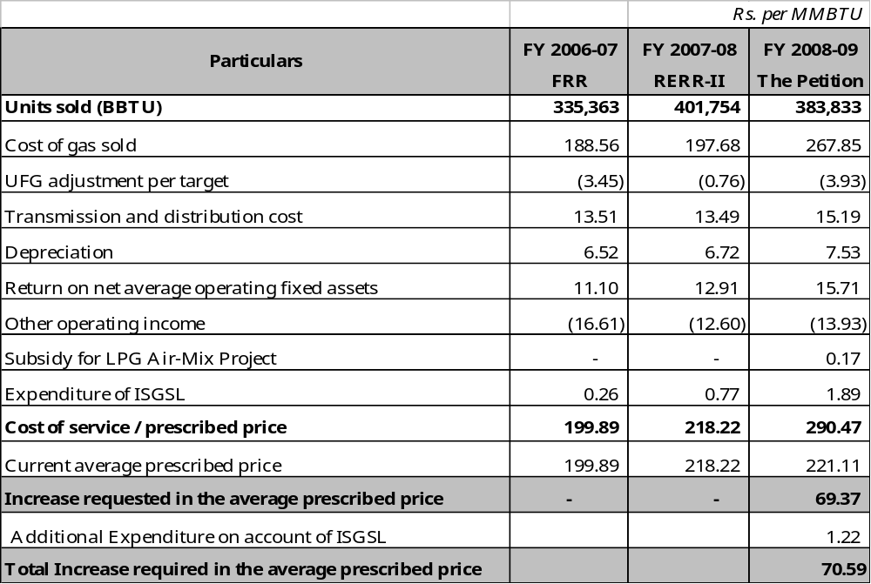
  - The Authority admitted the petition for consideration, as a prima facie case for evaluation existed and it was otherwise in order.
  - A notice inviting interventions / comments on the petition from the consumers, general public and other interested / affected persons, was published in daily newspapers, namely: Business Recorder (combined), Jang (combined), Express (Karachi) and Mashriq (Quetta), on March 06, 2008. The Authority received 19 applications to intervene in the proceedings from the following persons / entities:
- All Pakistan CNG Association, Rawalpindi
- All Pakistan Textile Mills Association, through Rashid Law Associates, Lahore
- Naveena Industries (Pvt.) Limited, Karachi
- Naveena Group, Naveena Exports Limited
- Anwar Textile Mills Limited, Karachi
- Sana Industries Limited, Karachi
- Ali Asghar Textile Mills Limited, Karachi
- Premium Textile Mills Limited, Karachi
- Nadeem Textile Mills Limited, Karachi
- Shadman Group, Karachi
- Surriya Textile Mills (Pvt.) Limited, Karachi
- Amin Textile Mills (Pvt.) Limited, Karachi
- Nagaria Textile Mills (Pvt.) Limited, Karachi
- Gulistan Power Generation Limited, Lahore
- Dostsons Cotton Mills (Pvt.) Limited, Karachi
- Ihsan Sons (Pvt.) Limited, Karachi
- S. Fazal Elahi & Sons, Lahore
- Nessar Ahmad, Karachi
- Mohammad Arif Bilwani, Karachi
- SITE Association of Industry, Karachi
The Authority accepted all the above mentioned applications for intervention.
  - A notice intimating the date, time and place of the public hearing, was published in the daily newspapers, namely: Business Recorder (combined), Jang (combined), Express (Karachi) and Mashriq (Quetta) on April 02, 2008.

Salient Features of the Petition
  - The petitioner has made the following main submissions:
    - The petitioner has claimed annual return at the rate of 17% of the net fixed assets, before corporate income tax, interest, markup and other charges on debt, in accordance with license condition No. 5.2.
    - The petitioner has projected a gross addition of Rs. 9,864 million in the fixed assets, and net addition, ex-depreciation, of Rs. 6,811 million, resulting in projected increase in the net operating fixed assets from Rs. 36,556 million in FY 2007-08 to Rs. 43,367 million during the said year. The petitioner has further claimed that, after adjustment of deferred credits, the net average operating fixed assets eligible for return work out to Rs. 35,466 million, and the required return to Rs. 6,029 million.
    - The petitioner has projected the net operating revenues at Rs. 90,056 million, as detailed below (and compared with previous years):
Table 2: Comparison of Projected Operating Revenues with Previous Years

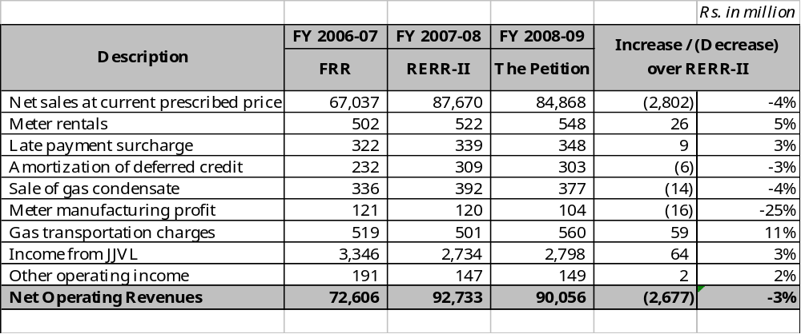

    - The petitioner has projected the net operating expenses at Rs. 111,058 million, as detailed below (and compared with previous years):
Table 3: Comparison of Projected Operating Expenses with Previous Years
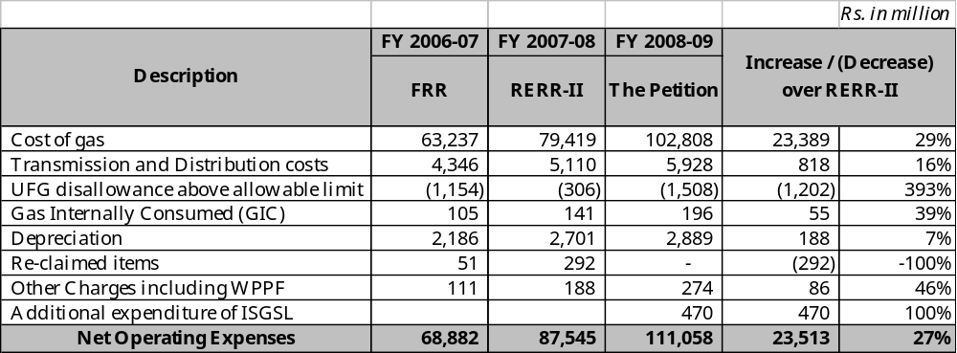
    - The petitioner has projected Weighted Average Cost of Gas (WACOG) for the said year at Rs. 243.75 per MMBTU, as against Rs. 181.04 per MMBTU provided in RERR-II FY 2007-08. The petitioner has explained that cost of gas is linked with international prices of crude / fuel oil according to Gas Pricing Agreements (GPAs) executed between the producers and Government of Pakistan (GoP).
    - The petitioner has projected Unaccounted for Gas (UFG) at 6.62% (28,876 MMSCF), higher than the upper target of 5.50% fixed earlier by the Authority for the said year.
    - The petitioner has requested for subsidy of Rs. 64 million on account of Air-Mix LPG Project, being undertaken by it in accordance with the directions of the Federal Government (GoP).
    - The shortfall in the projected revenue requirement to achieve 17% return on average net operating fixed assets is estimated at Rs. 27,095 million, requiring increase of Rs. 70.59 per MMBTU in the existing average prescribed price, as detailed below:

Table 4: Computation of Requested Average Increase in Prescribed Price

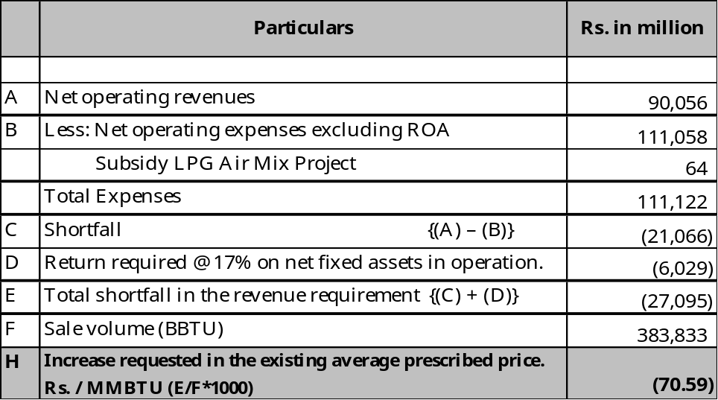

Hearing
  - The public hearing was held on April 16, 2008, at Karachi, which was participated by the following:
Petitioner:
- Petitioner’s team led by Mr. Azim Iqbal Siddiqui, Managing Director
Interveners:
- Syed Abdul Quddus, Admin Manager, Anwar Textile Mills, Limited
- Sheikh Naseem Anwar, Executive Director, Surriya Textile Mills (Pvt.) Limited, Karachi and Amin Textile Mills (Pvt.) Limited, Karachi
- Mr. Nesar Ahmed, Minority Shareholder / Director, SSGCL
- Mr. Abdul Amin, Company Secretary & Chief Accountant, Nadeem Textile Mills Limited and Nadeem Power Generation Limited
- Mr. Nadeem Ahmed, Manager Commercial, Nagina Cotton Mills Limited
- Mr. M. Arif Bilwani, Representative of Industry and Shareholder SSGCL
- Mr. M. Arshad, General Manager (Engineering), Al-Karam Textile Mills Limited, Karachi
- Mr. Samir Gulzar, Vice Chairman, All Pakistan CNG Association
- Mr. Shabbir Suleman Gee, Coordinator, All Pakistan CNG Association
- Mr. M. Nisar Sheikhani, Chairman, SITE Association of Industry
- Mr. Abdul Ghafoor, Manager, Sana Industries Limited
- Mr. Mahmood Rashid, Attorney, All Pakistan Textile Mills Association
- Mr. Mohammad Iqbal, Manager, Ihsan Sons (Private) Limited
  - The petitioner made submissions in detail with the help of multimedia presentation explaining the basis of the petition. The petitioner also responded to the comments, observations, objections, questions, and suggestions of the participants.
  - The substantive points made by the interveners / participants are summarized below:
- General Comments
    - GoP through its wholly owned Government Holding (Pvt) Company Ltd., is a shareholder in most of the exploration and production joint ventures and is earning huge revenues from the same. GoP also collects revenue at various stages as royalty, taxes, GDS, etc. Further, GoP is the majority shareholder of the petitioner company, and thus shares its profits. Therefore, GoP should relinquish its share of revenues and protect the gas consumers against the projected increase in price.
    - GoP has failed to re-negotiate the well-head price discounts in respect of Qadirpur field, owned primarily by public sector companies, despite lapse of almost two years even though it was required to do so within 6 months of the HSFO price going beyond US $ 200. GoP should urgently re-negotiate the Gas Pricing Agreement (GPA) of Qadirpur and also Kadanwari gas fields, as was done in case of HUBCO, since these producers are making windfall profits by supplying gas at extraordinarily high rates, resulting in sharp increase in cost of gas.
    - The participation of various stakeholders in the public hearings has never been really up to its potential and will decline unless the GoP truly empowers the Authority to address the grievances of public at large.
    - The provision for doubtful debts arises mainly in the case of domestic consumers because of high incidence of non-payment and the fact that the petitioner collects negligible security from them. The petitioner should increase the security deposit in line with the gas consumption pattern, and recover it in installments over a period of 4-5 years, through the monthly gas bills, with a view to avoid high provision for doubtful debts.
    - The petitioner has used US$ exchange rate of Rs. 66.5 for the period Jan, 09 to June, 09 for estimating cost of gas while it has computed the Royalty income from JJVL assuming Rs. 61.64 / US$ parity, which must be equated.
- Industrial Consumers -Specific Comments
    - In the worst of times, the domestic sector enjoys priority for supply of gas as well as substantial subsidy. This encourages excessive use at the cost of industrial and commercial consumers. This is unwise and unjust. Domestic tariff should be increased and stretched steeply to ensure efficient and frugal use at all times and particularly in winter when industries suffer supply crunch to accommodate increased domestic load. The domestic consumers should also be made to use efficient energy devices through all means available so that more gas volume is available for the industrial sector, which is incurring huge losses due to severe energy shortages.
    - Subsidy for use of gas as fertilizer feed-stock, at the cost of the industry, should be abolished. GoP should give direct subsidy to domestic and fertilizer consumers, through budget allocation, instead of the prevalent cross-subsidy mechanism of gas pricing.
    - Profits of the fertilizer factories are burgeoning as is evident from their annual accounts, and they are diversifying now in other sectors. Subsidy provided by the GoP has never been passed on to the farmers. It is not justified that the fertilizer factories continue to enjoy subsidy even after the expiry of ten year contract period in most instances. Their profits should be capped.
    - Tariff for consumption of gas in CNG sector should be fixed at the level of highest slab of domestic consumer since it is being used by affluent and well–to-do class only while petrol prices which are, energy content-wise more than double the CNG price, is used by the lower middle class like motor cycle owners and transporters who provide services to industry, business and common man. Slab-wise rate should also be applied on commercial consumers, since the low income small commercial consumers like barbers, tea stalls, etc, should not be treated equivalent to bigger commercial consumers like hotels.
    - Negligible projected growth of 2.7% in industrial sector sales volume as compared to 36% increase in CNG sector reinforces the industry’s argument. Distorted priority will further lead to reduced productivity, resultantly adversely affecting the exports as well as overall economy of the country.
    - Increase in gas prices would further increase the already very high cost of production of goods, reducing the industry’s competitiveness in the international market. The frequent increases in the prices of gas have adversely affected the industries and many of the industrial units have already closed down, increasing unemployment in the country. Any further increase will completely destroy the industry and serve as the proverbial last nail in the coffin.
    - Industrial gas price in Pakistan is very high compared with the neighboring countries, which is resulting in closure of textile units and reduction in exports, which accounts for 67% of the total exports of the country.
    - Pakistan has failed to meet export targets this year and a major decline is in the offing if further price increase is allowed. A number of SITE industrial plots are either being used for warehousing or they have been converted into retail markets, plazas etc. Some exporters are seriously considering to follow suit.
    - The Authority’s belief that all the GoP policies are binding upon it, is misconceived. Section 3(2) of the Ordinance clearly states that the Authority shall be independent in performance of its functions and under Section 21, it is obligated to follow the GoP policy guidelines only if and to the extent that they are consistent with the Ordinance, Rules and Regulations. Quite a few GoP polices are not consistent with the letter and spirit of the Ordinance, and therefore should not be followed by the Authority.
    - Section 7(2) of the Ordinance clearly lays down the criteria for determination of tariffs which includes sending of appropriate price signals, minimizing economic distortions, taking into account costs of alternate sources of energy and provision for protection of consumers against monopolistic pricing. The Authority, however, has failed to abide by the relevant provisions of its law by giving huge subsidies to fertilizer and domestic consumers, thereby creating all kinds of economic distortions and bringing industry at the verge of closure / collapse.
    - Supreme Court judgment (2005 SCMR 471) clearly stipulates that a policy is not implemented unless enforced through a notification.
    - The well-head pricing formula and petroleum policy must be immediately reviewed to bring down the cost to bearable level. The linkage of indigenous gas with international oil prices is irrational and unjustified. Increase in oil prices is resulting in windfall gains for gas exploration companies as there is no increase in their cost structure, their fields having been in production for quite some time. The annual accounts of the gas exploration companies are showing phenomenal growth in profits mainly due to lacunae in well-head pricing formula. The Authority must intervene in public interest, and reduce the well head prices to provide relief to consumers at large.
- CNG Industry-Specific Comment
    - CNG stations are required to pay the road cutting charges for gas connection, which should be borne by the petitioner since the charges relate to laying of the pipeline owned by the petitioner.
- Shareholders-Representatives Comments
    - The policies / directives of GoP should be implemented only if the related expenditure (capital and revenue) is provided by GoP itself because economically unsound and unwise policies of GoP for political expediency reasons are resulting in higher consumer prices and unacceptably low shareholder returns.
    - All the expenditures pertaining to supply of gas to new towns and villages provided in compliance of GoP directives, including additional UFG due to network expansion, should be borne by the GoP instead of gas consumers or shareholders. Similarly, the expenses on account of security, losses due to sabotage activities e.g leakages, damages, repair & maintenance, insurance, etc should be picked by the GoP because they accrue in consequence of GoP policies, and actions or lack of action
    - The petitioner was compelled to employ the Temporary Assignees (TA) in FY 1994-95 who were terminated after a four year period. The petitioner had to again induct quite a few of them, despite their lack of relevant knowledge / expertise for reasons beyond their control. The recurring cost of these TA’s should, therefore, be borne by GoP.
    - The Government should fund the infrastructure projects of national importance, such as LNG or ISGSL, through its budgetary allocations instead of burdening the existing consumers. The Government could easily utilize the funds available with Government Holding (Pvt) Ltd. earned from mandatory shares in producing fields.
    - The ADB loan covenants, under which 17% return was allowed, have expired. The return mechanism should be based on guaranteed shareholders fund per the new tariff regime, in line with PARCO, etc.
  - The Authority has carefully considered all the submissions and arguments of the parties made in writing and at the public hearing and proceeds to discuss the same and make its determination as follows.

Authority’s Jurisdiction and Determination Process
  - Section 8(1) of the Ordinance empowers the Authority to determine an estimate of the total revenue requirement of its licensees for a financial year, before its commencement, in accordance with the NGT Rules, and on that basis, advise the Federal Government (GoP), the prescribed price of natural gas for each category of retail consumers.
  - GoP, pursuant to Section 8(3) of the Ordinance, is legally empowered to advise the Authority for notification in the official gazette, the minimum charges and sale price for each category of retail consumers, deciding in this process, the extent of subsidy to be enjoyed or extra amount to be paid by various categories of consumers with respect to average cost of supply. This position is reinforced by Section 8 (6)(a) of the Ordinance, which clearly provides that the category of retail consumers means “a category of retail consumers for natural gas designated as such by the order of the Federal Government”. Thus, the plea of some interveners that this Authority should second guess the GoP advice, is misconceived and legally untenable. The Authority examines all applications and petitions in light of relevant rules. Public notices are issued and all the stakeholders are provided full opportunity to intervene / comment upon the issues pertaining to determination of revenue requirement, in writing and at public hearings, which are duly taken into account. Further, GoP’s attention is specifically drawn to the pleas relating to policy matters for consideration before deciding the retail prices for various categories of consumers.
  - GoP regulates the upstream oil & gas sector and Section 43A of the Ordinance specifically excludes those activities from the purview of OGRA. GoP concludes with the Exploration & Production companies the terms and conditions including the parameters for determination of gas price in accordance with its petroleum policies. OGRA, on the other hand, is empowered to regulate midstream and downstream petroleum sector. However, pursuant to Section 6(2)(w) of the Ordinance, OGRA is to “determine and notify the well-head gas prices for the producers of natural gas in accordance with the relevant agreements or contracts”. Therefore, the intervener’s plea that the Authority should act to reduce the well-head prices in public interest has no legal basis.
  - The operating revenues, operating expenses and changes in asset base are scrutinized by the Authority in depth. Appropriate benchmarks are also set in critical areas of operation to ensure that the cost of inefficiencies and imprudence are not passed on to the consumers. But for such controls, the operating expenses of the licensee could have been considerably higher.
  - Section 21 of the Ordinance “powers the Federal Government to issue policy guidelines“, is reproduced below in order to clarify the misconception expressed by some interveners.
“(1) The Federal Government may, as and when it considers necessary, issue policy guidelines to the Authority on matters of policy not inconsistent with the provisions of this Ordinance or the rules and the Authority shall comply with the policy guidelines in the exercise of its powers and functions and in making decisions.
        - Without prejudice to the generality of the foregoing, the Federal Government may issue policy guidelines in relation to-
            - planning for infrastructure development;
            - pricing of petroleum including development surcharge as defined in section 8 and the petroleum development levy as defined in the Petroleum Products ( Petroleum Development Levy) Ordinance, 1961 ( XXV of 1961);
            - standards and specifications for refined oil products;
            - supply of natural gas and refined oil producers to service new areas and provision of financial incentives in cases where the service is not economically viable;
            - establishment and maintenance of the strategic petroleum storage;
            - open access, common carrier and common operator;
            - marketing of refined oil product; and
            - tariff applicable to petroleum.
  - It is evident that the said Section 21 confers quite broad-based powers on GoP to issue policy guidelines to the Authority on various matters including pricing of petroleum and supply of natural gas to service new areas / town, and obligates the Authority to comply with the same unless a specific guideline is held to be inconsistent with the provisions of the Ordinance. The Authority always examines this aspect carefully before proceeding to comply with any policy guideline.
  - The Supreme Court decision (2005/SCMR 471) quoted by an intervener in this context is not applicable in the present case because Section 21 provides specifically for “issue” of policy guidelines to the Authority in writing pursuant to a decision of the Cabinet of the Federal Government or a Committee thereof. No formal gazette notification is required under the Ordinance.

Return to Licensee
  - The Authority is obligated under Section 7(1) of the Ordinance, to determine or approve tariff for regulated activities whose licenses provide for such determination or such approval, or where authorized by this Ordinance, subject to policy guidelines. License Condition No. 5.2 of license granted to the petitioner, clearly states that the Authority shall determine total revenue requirement of the licensee to ensure that it achieves 17% return on its average net fixed assets in operation for each financial year, subject to the efficiency related benchmarks adjustments. The Authority, accordingly, has been determining the revenue requirement of the petitioner, providing the said return on net operating assets in accordance with the said provision of the Ordinance as well as the petitioner’s license.

  - The Authority, may, however, in consultation with Federal Government (GoP) and the licensee prescribe revised rate of return or a different basis for determination of a return, pursuant to License Condition No. 5.3 of the license granted to the petitioner. The Authority has developed a new tariff regime for regulated natural gas sector of Pakistan, which, in the course of legally mandatory consultation process, is with GoP. Pending its finalization, the Authority has decided, to follow the existing basis of 17% return on the average net operating fixed assets, in accordance with the License Condition No. 5.2. The Authority does not subscribe to the view of some interveners that it should proceed to finalize the matter without having the benefit of GoP’s views because GoP is an important stakeholder. Firstly, it is exclusively empowered to lay down policies in all matters of national / public interest and secondly it controls the majority shareholding of the petitioner as well as Sui Northern Gas Pipelines Limited (SNGPL).

Operating Fixed Assets
  - Summary
    - The petitioner has projected a gross addition of Rs. 9,864 million in the fixed assets and ex-depreciation addition of Rs. 6,811 million, resulting in projected increase in net operating fixed assets from Rs. 36,556 million in FY 2007-08 to Rs. 43,367 million during the said year. After adjustment of deferred credits, the net average operating fixed assets eligible for return are projected at Rs. 35,466 million, and the required return at Rs. 6,029 million, as under:
Table 5: Computation of Projected Return according to the Petition on Operating Fixed Assets
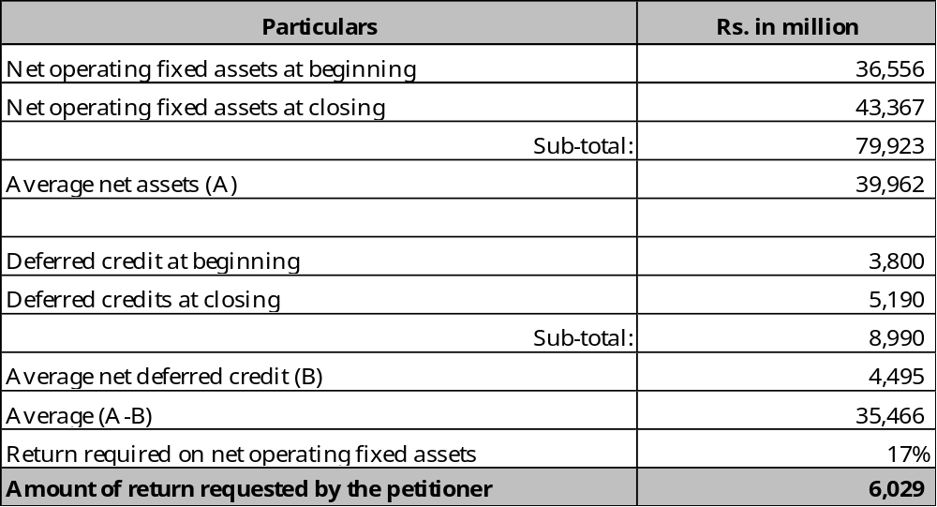

    - The details of deferred credits projected by the petitioner for the said year are compared with RERR-II FY 2007-08, as under:

Table 6: Comparison of Projected Deferred Credits with RERR-II FY 2007-08
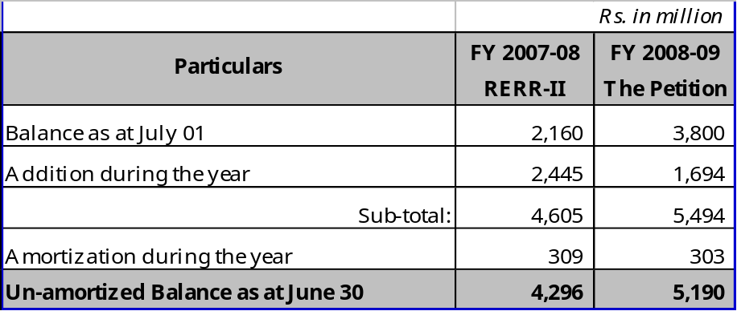

    - The Authority notes that the petitioner has incorrectly taken the opening balance of deferred credits, at Rs. 3,800 million instead of Rs. 4,296 million determined in RERR-II FY 2007-08. The opening balance for the said year is, therefore, determined at Rs. 4,296 million. Consequently, the amortization of deferred credit is also adjusted as shown in the revised computations given below:
Table 7: Computation of Deferred Credits Determined by the Authority
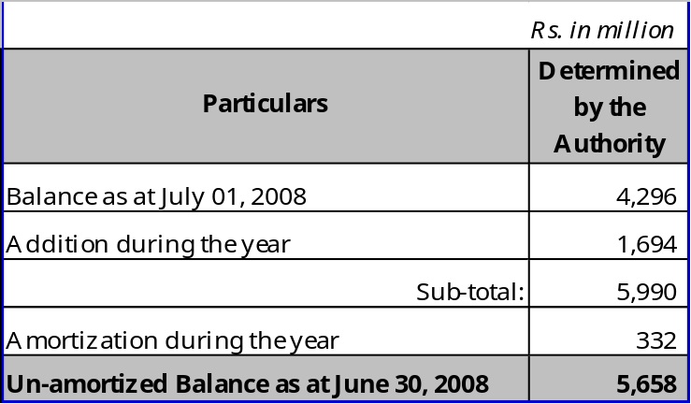
    - Comparative analysis of projected additions in fixed assets with the previous year is as follows:
Table 8: Summarized Schedule of Projected Additions Compared with Previous Years
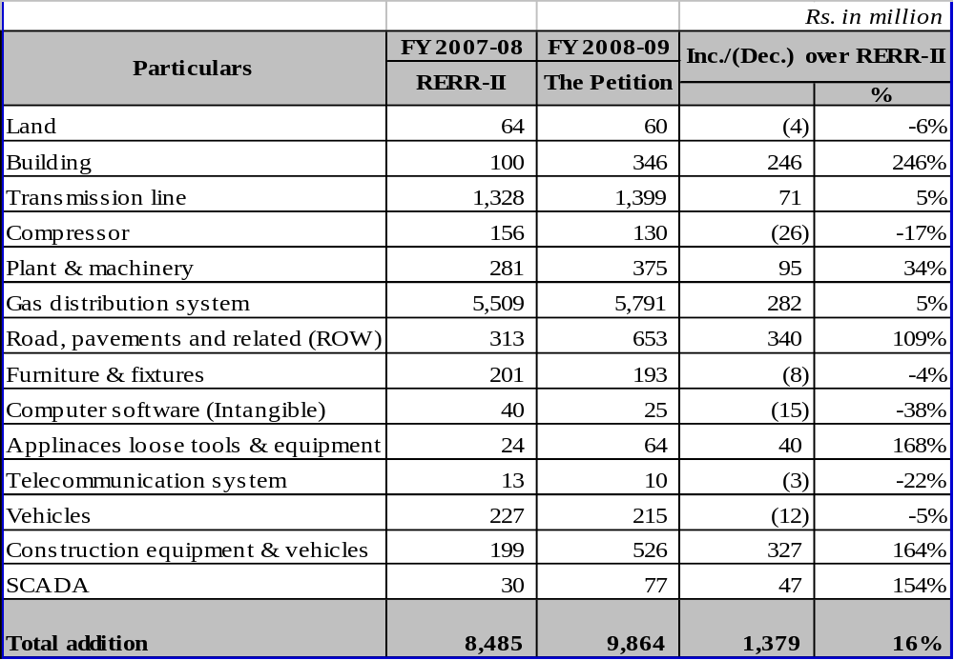

    - The petitioner has provided further breakdown of the major items of additions as at Annexure-D, which are discussed below:
  - Transmission
  - Summary
    - The petitioner has projected Rs. 1,399 million on account of additions to transmission network during the said year, breakup of which is as follows:
Table 9: Additions to Transmission Network Provisionally Allowed as Requested
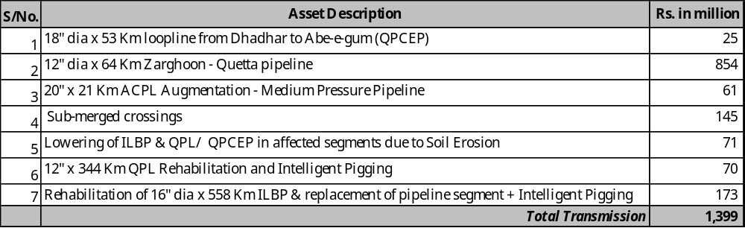
    - The Authority, after detailed scrutiny and exhaustive analysis of the petitioner’s projected transmission additions, provisionally accepts Rs. 1,399 million on this account.
  - Distribution Development
- Summary
    - The petitioner has projected an expenditure of Rs. 5,791 million (i.e. 5% increase over RERR-II FY 2007-08) for the said year on account of distribution network including new towns and villages, details of which are provided below:

Table 10: Detail of Additions to Distribution Network
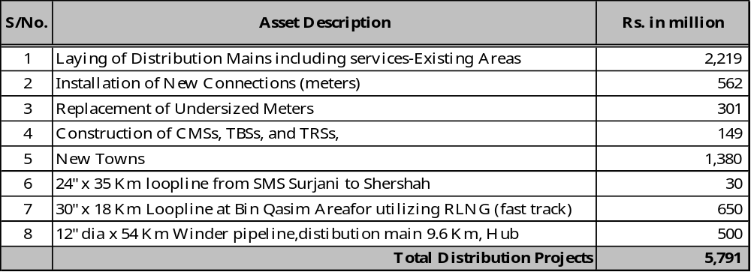
    - After due examination of the detailed justifications submitted by the petitioner, the Authority provisionally accepts the distribution assets for the said year at Rs. 5,791 million.
- Land
    - The petitioner has projected a sum of Rs. 60 million for the said year in respect of land. The Authority observes that in view of the petitioner’s past record of considerably less actualization compared to the projections at the time of ERR, the estimate for the said year appears to be overly optimistic. Historical analysis is as under:
Table 11: Historical Analysis of Land
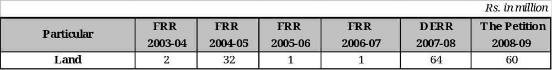
    - The Authority notes that the petitioner has only been able to incur an expenditure of Rs. 11 million approximately during first nine months of FY 2007-08 and it is planning to incur another Rs. 9 million in the remaining three months.
    - In view of above, it is evident that the amounts projected by the petitioner under this head are exaggerated. The Authority, therefore, provisionally determines the expenditure on account of land for the said year at Rs. 30 million.
- Road, Pavements and Related (Right of way - ROW)
    - The petitioner has projected an amount of Rs. 653 million for the said year in respect of road, pavements and related ROW.
    - After scrutiny of the information provided by the petitioner, the Authority observes that out of total estimates of Rs. 653 million, 50% of Rs. 428 million i.e. Rs. 214 million will be borne by M/s Pakistan Petroleum Limited, in accordance with the PM directives. Therefore, the Authority provisionally determines Rs. 440 million under this head for the said year, as under;
Table 12: ROW Allowed by the Authority
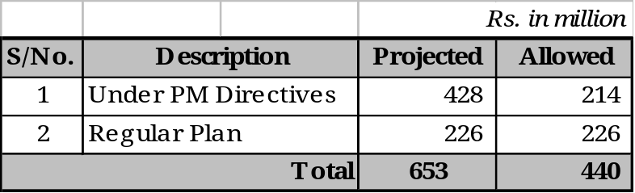
- Building
    - The petitioner has projected an expenditure of Rs. 346 million for the said year in respect of building, seeking a very high increase of 246% against Rs. 100 million provided in RERR-II FY 2007-08.
    - The Authority observes that the estimate under this head is inexplicably high and does not commensurate with the previous performance of the petitioner, as would be clear from the historical analysis given below;
Table 13: Historical Analysis of Building
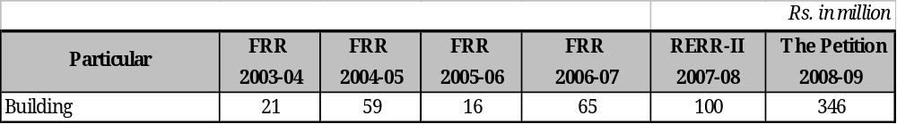
    - Keeping in view the previous capitalization trends under this head as well as the capacity of the petitioner to take projected activities/ projects to completion, the Authority provisionally determines expenditure on this account for the said year at Rs. 100 million.
- Plant & Machinery
    - The petitioner has projected a sum of Rs. 375 million for the said year in respect of plant & machinery, involving an increase of 33% against Rs. 281 million provided in RERR-II FY 2007-08.
    - The Authority observes that the petitioner’s projections have always been far higher than actual capitalization. The historical position is given below;
Table 14: Capitalization trend of Plant & Machinery
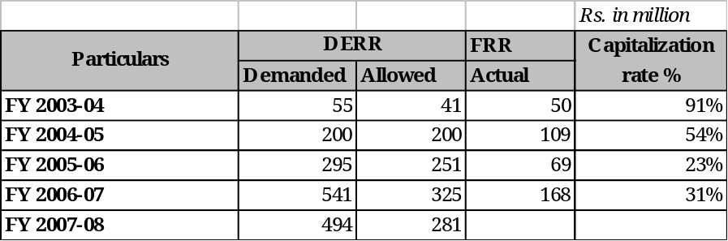
    - Based on the above, the Authority, provisionally determines expenditure at Rs. 263 million against the projection of Rs. 375 million, on this account.
- Furniture, Equipment including Computers & Allied Equipment
    - The petitioner has projected an amount of Rs. 193 million for the said year under the above head, involving an increase of 31% against Rs. 147 million provided in RERR-II FY 2007-08.
    - The detail breakup of Rs. 193 million is as under;
Table 15: Furniture & Equipment including Computers with Allied Equipment
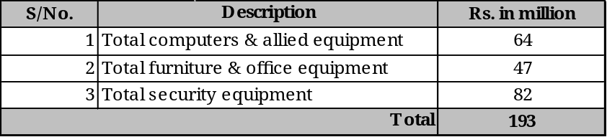
    - The Authority observes that out of Rs. 47 million, Rs. 9 million pertains to printers, UPS, etc, which is a part of I.T expenditure and not furniture and office equipment The expenditure amounting to Rs. 120 million (i.e. Rs. (47+82-9) million) projected by the petitioner, under sub-head of “furniture and equipment” seems to be reasonable, and therefore the Authority provisionally accepts the same. The balance amount of Rs. 73 million (i.e. Rs. (64+9) million) pertaining to I.T related expenditure is discussed and decided separately in para 6.4 below.
- Appliances, Loose Tools & Equipment
    - The petitioner has projected an amount of Rs. 64 million in respect of appliances, loose tools & equipment for the said year, involving an increase of 167% against Rs. 24 million provided in RERR-II FY 2007-08.
    - The Authority observes that the petitioner has over - projected the amount under this head. The historical analysis is as under;
Table 16: Historical Analysis of Appliances, tools & Equipment
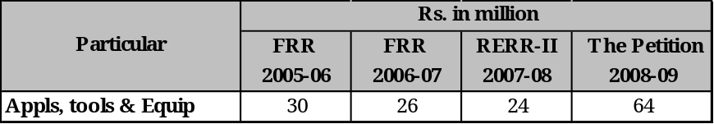
    - The Authority, keeping in view the historical analysis, enhanced activity as well as inflation adjustment, provisionally determines expenditure under this head at Rs. 30 million for the said year, thereby adopting the highest amount in the recent past.
- Telecommunication System
    - The petitioner has projected expenditure of Rs. 10 million for the said year on account of telecommunication system. The petitioner has stated that this additional cost is considered necessary to meet the future and additional requirements of the executives at its head office and other site offices.
    - However, the Authority observes that the petitioner has failed to provide any concrete justification in support of its claim. The Authority, therefore, provisionally determines the projected amount at Rs. 5 million for the said year.
- Construction Equipment & Vehicles
    - The petitioner has projected construction equipment and vehicles for the said year at Rs. 526 million, against Rs. 199 million provided in RERR-II FY 2007-08, involving an increase of 164%.
    - The petitioner has submitted that new construction equipments are essentially required as the existing equipment has become quite old, redundant and uneconomical to operate.
    - The Authority observes that the amount projected by the petitioner under this head is very high in view of the fact that tangible justification has not been provided by the petitioner.
    - The Authority, in view of above, provisionally determines the said expense at Rs. 239 million for the said year.
- Remaining Assets
    - The Authority provisionally accepts additions pertaining to compressor, SCADA and vehicles at Rs. 130 million, Rs.77 million & Rs. 215 million respectively, as requested by the petitioner, as these projections seem reasonable.
  - IT Related Expenditure
    - The petitioner has projected Rs. 149 million in respect of capital and revenue IT related expenditure for the said year. The amount has been shown by the petitioner under different heads, for some inexplicable reasons, as under:
Table 17: Detail of Projected IT Related Expenditure according to the Petition
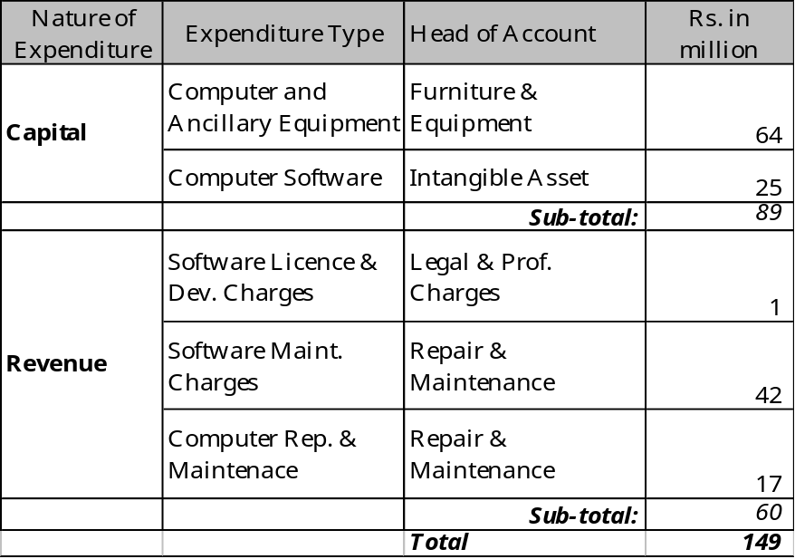
    - The petitioner has claimed Rs. 25 million on account of computer software and Rs. 17 million for software maintenance charges pertaining to GIS and ERP. The Authority observes that all I.T projects including GIS and ERP are currently under Authority’s comprehensive review and decision on the same will be issued separately.
    - The Authority, therefore, defers decision on computer software amounting to Rs. 25 million and Rs. 17 million software maintenance charges (under the head “Repair & Maintenance”) on account of GIS and ERP and for the present excludes these amounts for computation of Revenue Requirement for the said year.
    - The claim of estimated capital expenditure amounting to Rs. 73 (i.e. Rs. 64+9, refer para 6.3.16 above) million and Rs. 43 million revenue expenditure in respect of I.T seems to be reasonable and therefore, the Authority provisionally accepts the same for the said year.
  - Fixed Assets Determined by the Authority
    - The value of additions in assets requested by the petitioner and provisionally determined by the Authority for the said year, is as under:
Table 18: Summary of Asset Additions Determined by the Authority
Rs. in million
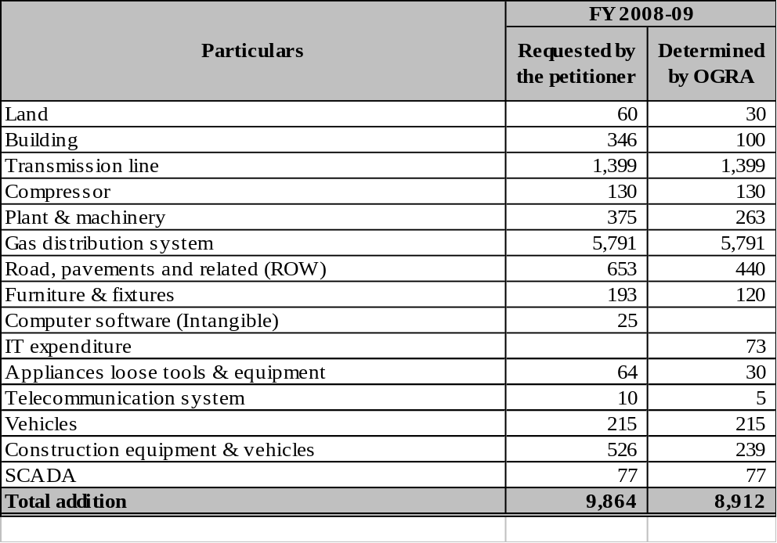
    - Depreciation expense claimed by the petitioner comes down by Rs. 118 million to Rs. 2,770 million as a consequence of reduction in additions to fixed assets for the said year, as discussed above.
    - In view of the above, the Authority provisionally determines closing net operating fixed assets (net of deferred credits) for the said year at Rs. 36,866 million duly taking into account the adjustment referred in para 6.1to 6.4 above.
- Operating Revenues
  - Sales Volume
    - The petitioner has projected increase in number of consumers from 2,024,741 provided in RERR-II FY 2007-08 to 2,148,253 during the said year, as follows:
Table 19: Comparison of Projected Number of Consumers with Previous Years
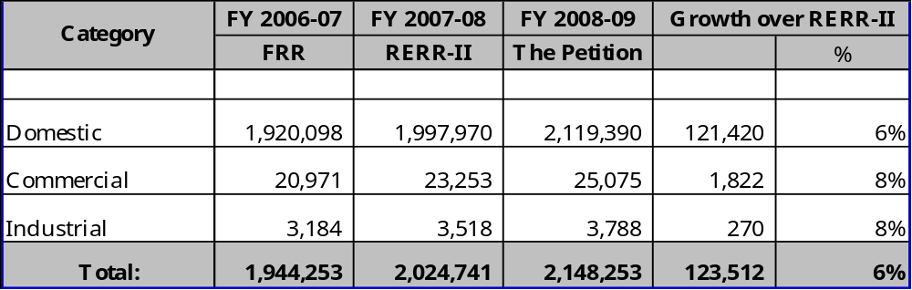
    - The sales volume for the said year has been projected at 383,833 BBTU, as against 401,754 BBTU, according to RERR-II FY 2007-08, lower by 4.5%. Category-wise comparison with previous years has been provided as under:
Table 20: Comparison of Sales Volume with Previous Years
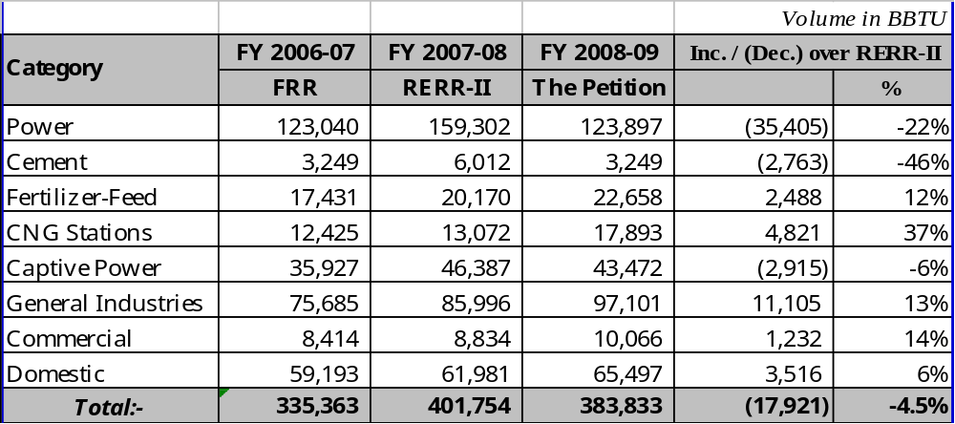
    - The petitioner has explained that the projected decrease in sales volume is due to anticipated delay in gas supply from certain fields during the said year.
    - The Authority observes that the sales volume projected by the petitioner seems to be reasonable and, therefore, provisionally accepts the same for the said year.
  - Sales Revenue at Existing Prescribed Prices
    - The petitioner has projected sales revenue at existing prescribed prices to decrease by 3.2%, from Rs. 87,670 million provided in RERR-II FY 2007-08 to Rs. 84,868 million for the said year. Category-wise comparison of sales revenue is given below:
Table 21: Comparison of Projected Sales Revenue with Previous Years
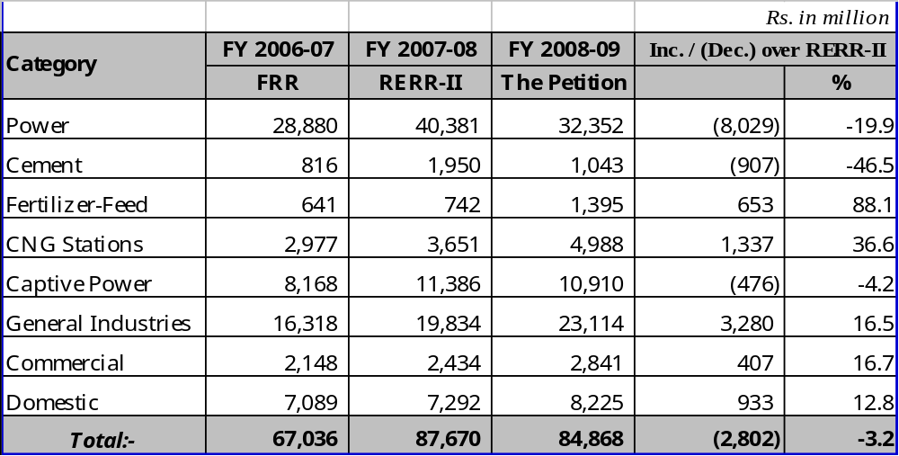
    - The Authority observes that the said decrease in revenue is due to decrease in sales volume as discussed in para 7.1.3 above.
    - The Authority provisionally accepts the projected sales revenue at Rs. 84,868 million for the said year.
  - Other Operating Income
- Summary
    - The petitioner has projected other operating income at Rs. 5,189 million during the said year as against Rs. 5,064 million provided in RERR-II FY 2007-08. Comparison with previous years is given below:
Table 22: Comparison of Projected Other Operating Income with Previous Years
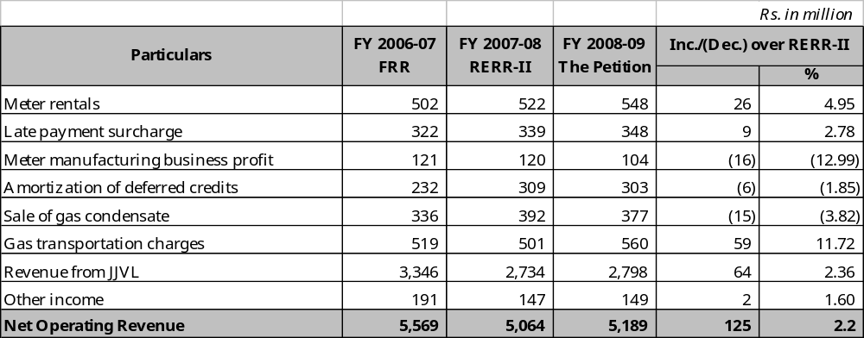
- Revenue from JJVL
    - The petitioner has like in previous petitions, treated projected royalty income from JJVL amounting to Rs. 2,059 million as non-operating income for the said year arguing again that this is a payment against its right to extract LPG from condensate and can not be taken as profit from gas operations.
    - The Authority notes that it has already exhaustively discussed and decided the issue of royalty from JJVL in its earlier decisions. The arguments advanced now have previously been considered, discussed and decided. Therefore, there is no reason to consider it again. The Authority maintains its earlier decision, and treats Royalty income from JJVL as part of operating income.
    - Consequently, the Authority provisionally determines the total revenue from JJVL at Rs. 4,857 million as under;
Table 23: Revenue from JJVL
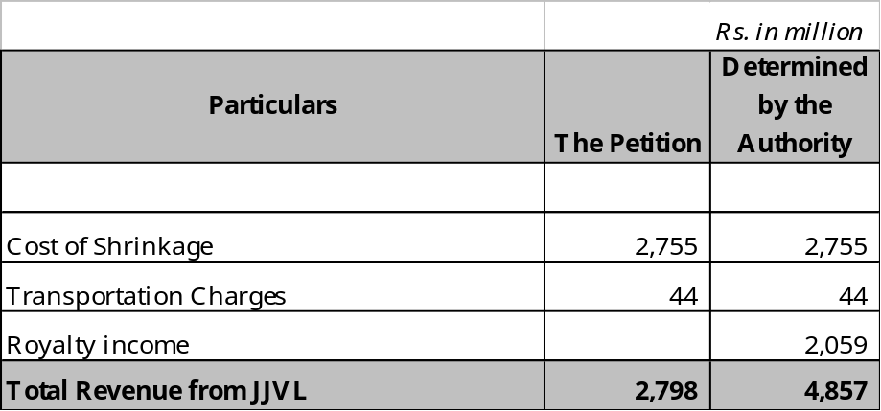
- Amortization of Deferred Credit
    - The petitioner has projected Rs. 303 million on account of amortization of deferred credit for the said year as against Rs. 309 million provided in RERR-II FY 2007-08, showing decrease of 6%.
    - In view of the discussion in para 6.1.3 above, the Authority provisionally determines Rs. 332 million on this account for the said year.
- Other Income
    - The petitioner has projected increase in other income from Rs. 147 million provided in RERR-II FY 2007-08 to Rs. 149 million during the said year. Comparison with previous years is given below:
Table 24: Comparison of Projected Other Operating Income with Previous Years
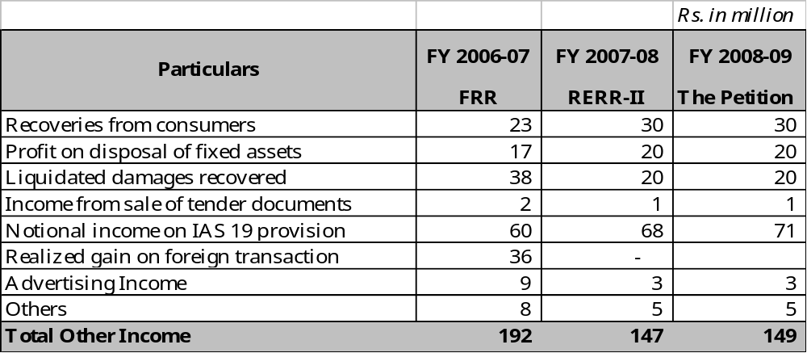
    - The petitioner has projected Rs. 3 million as Advertising Income from publicity on gas bills keeping it constant w.r.t DERR FY 2007-08 and RERR-II FY 2007-08. The Authority observes that the petitioner has been earning handsome amounts on this account in previous years, including Rs. 9 million during the FY 2006-07. There is no apparent reason for not realizing the potential of this income stream. Therefore, the Authority provisionally determines it for the said year at the level of FY 2006-07, i.e. Rs. 9 million.
    - The petitioner has computed the projected interest income on IAS-19 funds @ 7.77%. The Authority, in view of the increased borrowing rates, provisionally determines projected income on IAS-19 funds at Rs. 91 million @ 10% p.a, as part of other operating income.
    - The Authority observes that the remaining items under the head “other income” have been reasonably projected and therefore provisionally determines the said income at Rs.175 million for the said year.
    - In view of the discussion in paras 7.3.2 to 7.3.10 above, the Authority provisionally determines other operating income for the said year at Rs.7,302 million.
  - Air-Mix LPG Project
    - The petitioner has submitted that in order to comply with the President of Pakistan’s directive to provide piped gas to remote towns, an Air-Mix LPG pilot project was successfully installed & commissioned for Gawader in FY 2006-07. The petitioner has further planned to install similar plants in Zhob and Mithi during the said year. The revenue and capital expenditures of these three projects have been claimed as part of revenue requirement for the said year, requiring subsidy of Rs. 64 million or Rs. 0.17 per MMBTU from gas operations.
    - The Authority observes that in pursuance of President’s directive, a private party had committed to donate LPG plants to the petitioner for supply of Air-Mix LPG to Zhob and Mithi on the basis of which the petitioner has planned these projects for the said year. However, on current indications, it is unlikely that these projects will materialize in this year. The Authority, therefore, pends inclusion of subsidy on account of Zhob and Mithi for the said year.
    - The Authority, vide its decision on Motion for Review of FRR FY 2006-07 dated November 19, 2007, had pended the issue of Gawader Air-Mix LPG project till receipt of clear policy guidelines from GoP. The Authority had apprised the GoP that Air-Mix LPG could not technically be categorized as natural gas under the Ordinance.
    - The Cabinet Division vide its letter no. 1/15/2007-RA-II/OGRA dated January 12, 2008, has since issued the policy guidelines approved by the ECC of the Cabinet on Air-Mix LPG, CNG or LNG based pipeline distribution projects undertaken by the petitioner and SNGPL, as reproduced below:
- These guidelines are applicable only to stand-alone pipeline distribution projects for supply of piped LPG Air Mix, LNG or CNG to retail consumers on specific directions of the President, Prime Minister, Cabinet or the ECC of the Cabinet.
- Retail tariff applicable in case of these projects will be the same as that of natural gas being supplied to various categories of consumers through existing transmission and distribution network.
- All expenditure incurred on installing, maintaining and operating these projects including cost of gas shall be included as permissible expenditure in the revenue requirements of the respective gas companies.
- The gas utilities shall ensure prudency in all such expenditure to the satisfaction of the Regulatory Authority and also ensure ring fencing of all capital and revenue expenditures, including all cost allocations in respect of each such project.
- SSGCL and SNGPL will be entitled to a rate of return equal to the rate of return applicable for gas operations.
    - In view of above policy guideline, the Authority determines the net estimated revenue requirement on account of Gawader Air-Mix LPG project for the said year at Rs. 24 million, subject to actualization in due course. The petitioner is directed to ensure prudence and ring fencing of all capital and revenue expenditures, including all cost allocations in respect of such projects.

- Operating Expenses
  - Cost of Gas
    - The petitioner has projected cost of gas for the said year to increase from Rs. 79,419 million provided in RERR-II FY 2007-08 to Rs. 102,808 million, based on its projection of prices of crude and HSFO. Comparative analysis of projected cost of gas with previous years is given below:
Table 25: Comparison of Cost of Gas with Previous Years
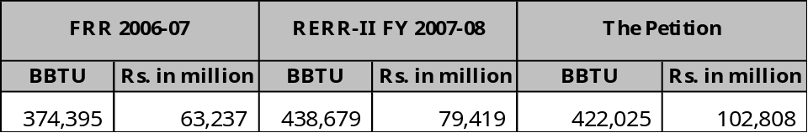

    - The well-head gas prices on the basis of which cost of gas is determined are indexed to the international prices of crude and HSFO per GPAs between the GoP and the producers and are notified semi-annually, effective on 1st July and 1st January. The international average prices of crude and HSFO during the immediately preceding period of December to May are used as the basis for calculating the well-head gas prices for the period July to December, and similarly oil prices during the immediately preceding period of June to November are used to calculate the well-head gas prices for the period January to June.
    - The petitioner computed WACOG at Rs. 243.75 / MMBTU for the said year projecting international prices of HSFO & crude and PKR / US $ exchange rate as under:
Table 26: Estimates for Determination of WACOG according to the Petition
Applicable for wellhead gas price for the period | Average C&F oil prices for the period. | Average C&F price of Crude Oil  (US $ per BBL) | Average C&F price of HSFO  (US $/M.Ton) | Exchange  Rate  (Rs /US $)
Jul 08 to Dec 08 | Dec 07 - May 08 | 95.54 | 531.35 | 64.50
Jan 09 to Jun 09 | Jun 08 - Nov 08 | 107.40 | 555.43 | 66.50

    - Comparative analysis of applicable prices of crude and HSFO, used for fixation of well-head gas prices on semi-annual basis, as discussed in para 8.1.2 above is provided below:
Table 27: Analysis of applicable Crude Oil & HSFO Prices
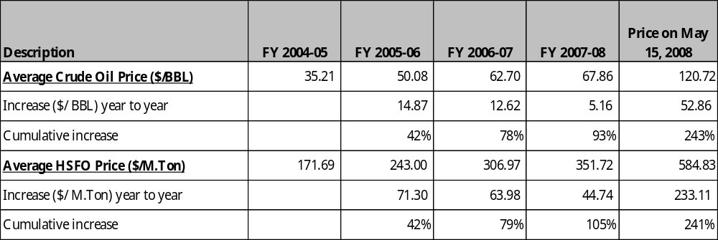
    - The Authority observes that the WACOG estimated by the petitioner at Rs. 243.75 / MMBTU appears to be reasonable and therefore provisionally accepts the same for the said year. The Authority, however, observes that in the event of continuously rising oil prices in the international market coupled with deteriorating rupee to US$ exchange rate, there is a likelihood of upward adjustment of WACOG from January 01, 2009. Detailed computation of WACOG is at Annexure-E.
    - Based on the above discussion, the cost of gas is provisionally determined for the said year at Rs. 102,808 million. The petitioner is, however, directed to submit a review petition to the Authority latest by October 15, 2008 for review of its estimated revenue requirements as required under Section 8(2) of the Ordinance, keeping in view the actual and anticipated changes in international prices of crude and fuel oil during the period June to November, 2008 and the trend of Rupee – Dollar exchange rate.
  - Unaccounted for Gas (UFG)
    - The petitioner has projected the UFG for the said year at 6.62% ( 28,876 MMCF), as follows:
Table 28: Comparison of Unaccounted for Gas with Previous Year
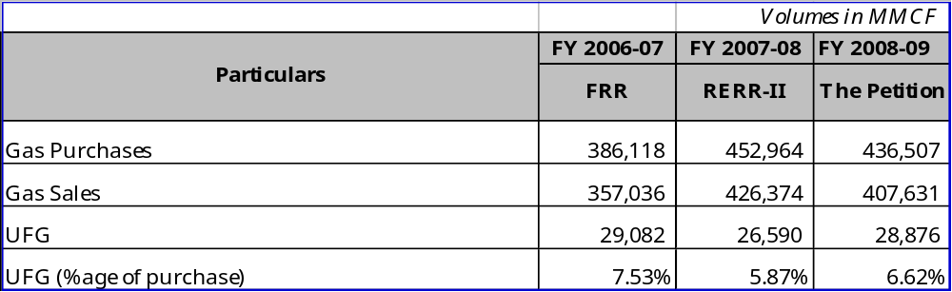
    - The petitioner has stated that UFG for the said year has been computed by taking the effective UFG target for FY 2008-09 i.e. 5.15% set by the Authority, per Order on motion for review of DERR 2005-06, dated October 19, 2005 and impact of 50% of excessive UFG (i.e. 1.47%) has not been included in the revenue requirement. It has also requested the Authority to review the benchmark related to UFG on yearly basis according to its license condition No. 21.1 because targets determined by OGRA are unachievable in the short term due to ground realities and pervasive theft culture.
    - The Authority, after giving due weight to all relevant factors including the contentions of the two utilities, had fixed the UFG benchmark in its order on motion for review of DERR FY 2005-06, dated October 19, 2005, on a long term basis. The petitioner has not raised any new substantive point in this regard while persisting with its request to review the targets as fixed. For the said year, the upper and lower targets of UFG had been fixed at 5.50% & 4.80%, respectively, with the condition that the petitioner would be entitled to retain the savings in the event of performance being better than the lower target, fully bear UFG above the upper target from its own profits whereas UFG between the lower & upper target be adjusted in the revenue requirement to the extent of 50% and the balance 50% be borne by the petitioner from its own profit.
    - Keeping in view the above decision, the Authority observes that petitioner’s computation of UFG disallowance for the said year at 6,396 MMCF is not correct. According to the benchmark, 100% UFG above 5.50% (upper target) and 50% UFG between 5.50% and 4.80% (lower target) should not have been made part of revenue requirement. There is no provision for taking the average of upper & lower target in the Authority’s decision and hence is not acceptable.
    - The petitioner has claimed estimated loss due to sabotage activity / ruptures at 318 MMCF for the said year. The Authority observes that projection of gas volumes against sabotage activities / ruptures is not justified, since no realistic volume can be estimated on this account at the time of estimated revenue requirement. The Authority, therefore, does not admit the projected loss of 318 MMCF, and will consider it on the basis of actual volumes at the appropriate time.
    - The petitioner has further requested to allow 150 MMCF being estimated un-metered GIC, pertaining to third party damages. The Authority observes that it has already deliberated and decided this issue in para 6.2 of its Order on RERR 2007-08, dated September 06, 2007.
    - In view of above, the Authority maintains its earlier decision and does not admit the claim of 150 MMCF towards third party damages.
    - Revised UFG computation on the basis of above and adjustments according to para 8.3.33 below pertaining to gas internally consumed discussed below, is as under;
Table 29: Unaccounted for Gas Losses (UFG)
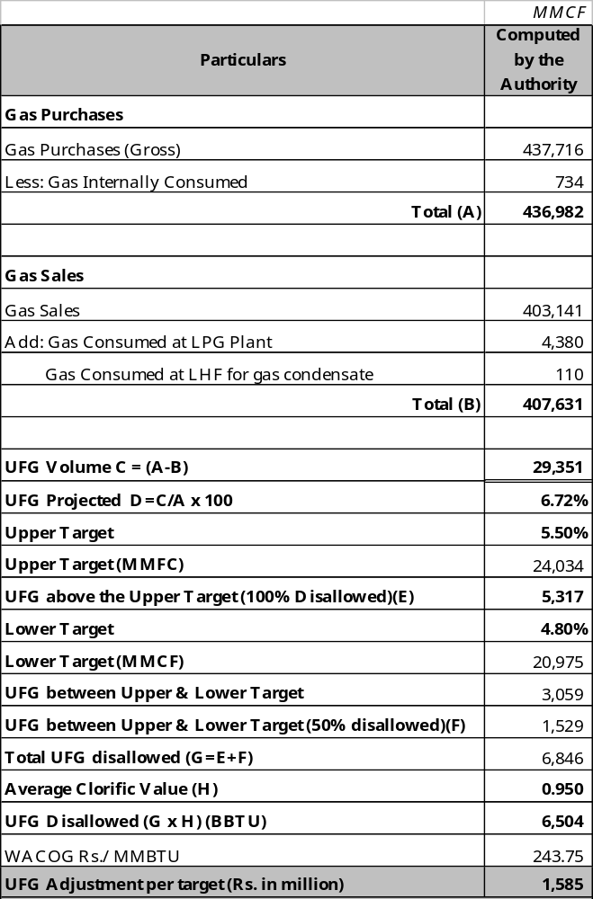

    - Based on the above computation, the Authority provisionally deducts Rs. 1,585 million from the revenue requirement of the petitioner for the said year.
  - Transmission and Distribution Cost
- Summary
    - The petitioner has projected increase in transmission and distribution cost (including gas internally consumed) by 23%, from Rs. 5,542 million provided in RERR-II FY 2007-08 to Rs. 6,594 million for the said year, as detailed below:-
Table 30: Comparison of Projected T&D Cost with the Previous Years
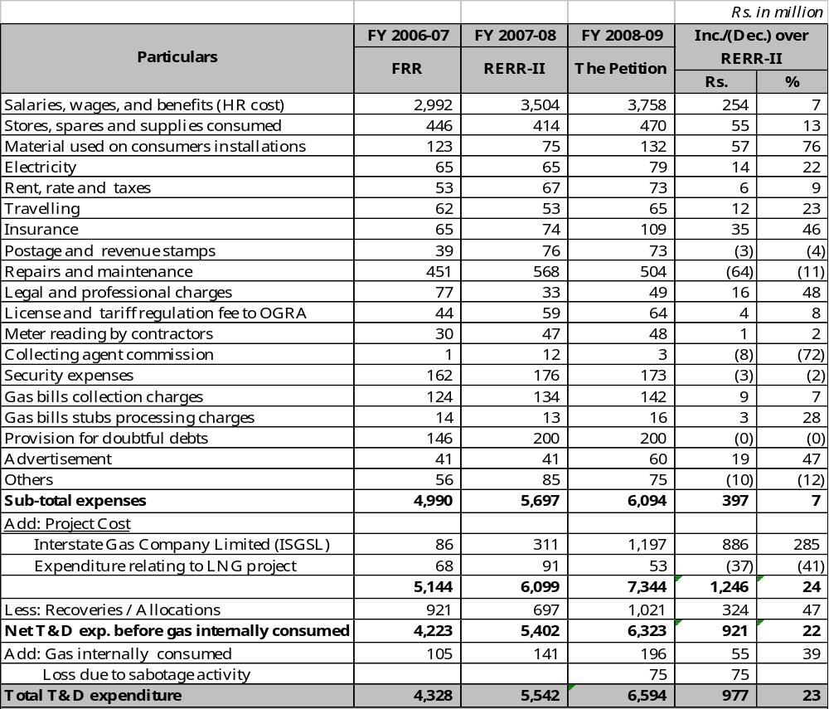
    - Various components of operating cost are discussed in the following paras:
- Human Resource (HR) Cost
    - The petitioner has projected the HR benchmark cost to increase from Rs. 3,504 million provided in RERR-II FY 2007-08 to Rs. 3,758 million for the said year, showing an increase of 7%. The petitioner has again contended that HR benchmark cost should be allowed on the basis of 100% CPI, instead of 50% set by the Authority
    - The Authority notes that it has already discussed and decided this issue in its various earlier determinations. The Authority observes that the existing benchmark has proved to be quite balanced and judicious. The petitioner has performed well within its parameters, as during FY 2005-06 and FY 2006-07 it saved a sum of Rs. 150 million and Rs. 123 million respectively on this account even though it is yet to make a major HR rationalization effort.
    - In view of the above, the Authority provisionally determines the HR cost for the said year on the basis of the benchmark at Rs. 3,758 million, subject to review after the actual results for FY 2007-08 and all other related information already sought from the petitioner separately are available.
    - The petitioner is directed to provide at the time of FRR, an unconditional (without “exception”, “subject to” provisions) certificate by its statutory auditors to the effect that HR cost used for comparison with HR benchmark, includes all regular, contractual and casual staff / labour.
- Insurance
    - The petitioner has projected insurance expense at Rs. 109 million for the said year as against Rs. 74 million provided in RERR-II FY 2007-08 showing increase by 40%, as under:
Table 31: Comparison of Insurance Expense with the Previous Years
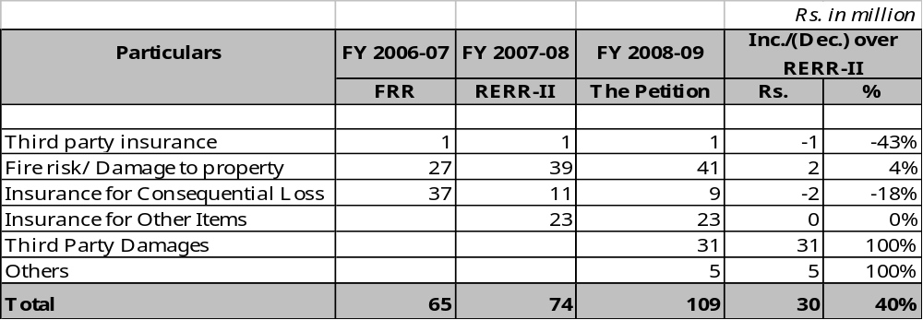
    - For the first time, the petitioner has resorted to claiming third party damages amounting to Rs. 31 million under the head of insurance. Previously this expenditure was always claimed as part of UFG computations and has been repeatedly disallowed by the Authority because UFG benchmark covers normal operational un-metered gas losses including normal third party damages, purging, leakages, etc. From accounting principles / standards viewpoint, booking actual expenses under the head “insurance” is simply not defendable.
    - In view of the above, the Authority does not admit the claim of third party damages amounting to Rs. 31 million and provisionally determines the insurance expense at Rs. 78 million for the said year.
- Advertisement
    - The petitioner has projected advertisement expense at Rs. 60 million for the said year as against Rs. 41 million provided in RERR-II FY 2007-08, increasing by 47%, as shown below:
Table 32: Comparison of Advertisement Expense with the Previous Years
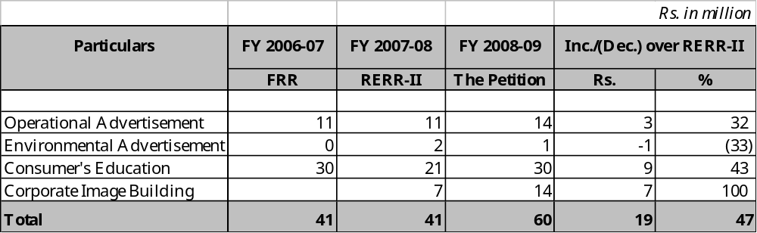
    - The Authority observes that actual advertisement expense for FY 2006-07 was Rs. 41 million and the actual expense for first six months (July-December) of FY 2007-08 has been Rs. 11 million only. It is therefore evident that the projections for the said year and that of FY 2007-08 are on the higher side. In view of above, the Authority provisionally determines the advertisement expense for the said year at Rs. 45 million, on the basis of 10% increase over actual expenditure for FY 2006-07.
- Repair & Maintenance
    - The petitioner has claimed repair & maintenance expenditure at Rs. 504 million for the said year. The Authority, in accordance with the discussion and decision in para 6.4.3 above, disallows Rs. 17 million on account of software maintenance charges and provisionally determines the repair & maintenance expense at Rs. 487 million for the said year.
- Legal & Professional Charges
    - The petitioner has projected legal and professional charges for the said year at Rs. 49 million as against Rs. 33 million provided in RERR-II FY 2007-08, showing an increase of 48%. Historical comparison of legal and professional charges is given below:
Table 33: Comparison of Projected Legal & Professional Charges with Previous Years
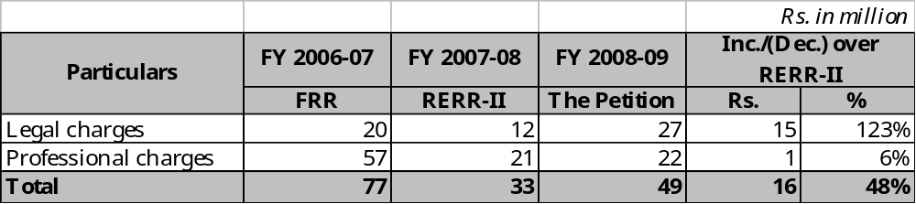
    - The petitioner has attributed the sharp increase in legal expenses to the ICC Arbitration in the matter of Habibullah Coastal Power Company (HCPC) amounting to Rs. 18 million. These expenses were not envisaged at the time of DERR FY 2007-08.
    - The petitioner informed that HCPC lodged claims for short gas supplied to it, on the ground that under the Gas Supply Agreement the petitioner was bound to supply a minimum quantity of 21 MMSCF of gas per day, failing which the HCPC had the right to claim the price differential of alternate fuel. HCPC lodged first claim in January, 2004 against curtailment of gas in December, 2003 by the petitioner. The petitioner rejected the claim on the grounds of Force Majeure due to terrorist activities and/or extreme winter conditions. The said Gas Supply Agreement is governed under the laws of England and arbitration is to be done under ICC rules at Singapore. The latest position is that total claim of HCPC on account of reduced supply has risen to Rs. 231 million. The petitioner has also informed that it is making efforts to resolve the dispute fairly and amicably at the earliest. It would only too fair to wait for the result of the dispute before making judgment as to prudence of all related expenditure and apportion blame.
    - In view of the above, the Authority provisionally allows the claimed estimated amount of Rs. 49 million on account of legal and professional charges for the said year.
- Provision for Doubtful Debts
    - The petitioner has projected provision for doubtful debts for the said year at Rs. 200 million, which is equivalent to that of RERR-II FY 2007-08. Historical comparison of provision for doubtful debts with previous years is provided below:
Table 34: Comparison of Provision for Doubtful Debts with Previous Years
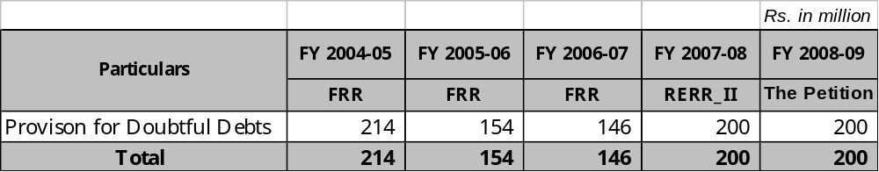
    - The Authority, in view of the alarming increase in provision for doubtful debts, has repeatedly directed the petitioner in its various earlier determinations to make concerted efforts to curtail the ever-increasing provision for doubtful debts in order not to pass this avoidable cost to the consumers. However, the estimated high level of provision for the said year points to continued lack of action to evolve effective mechanism to ensure timely recovery of bills. This cannot be allowed to continue.
    - In view of above, the Authority strongly reiterates its earlier direction that the petitioner should take all possible steps to curtail the provision for doubtful debts, and tentatively restricts the said provision at the level determined in FRR 2006-07 i.e; Rs. 146 million.
- Inter State Gas Systems (Pvt.) Limited (ISGSL)
    - The petitioner initially projected Rs. 727 million on account of reimbursement of 51% share in expenditure of ISGSL for the said year as against Rs. 311 million provided in RERR-II FY 2007-08, as shown in table below:
Table 35: Comparison of ISGSL Expenditure with Previous Years
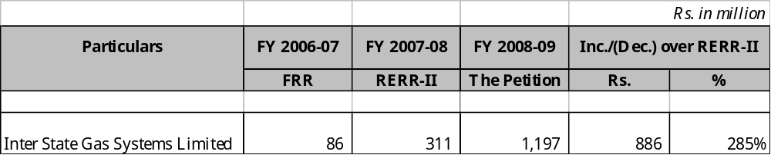
    - As referred in para 1.4 above, the petitioner is now seeking Rs. 1,197 million, pursuant to ISGSL Board of Director’s approval of the said expenditure, a whopping increase of 285% over previous year. Previously small amounts have been claimed as share in expenditure of ISGSL by the petitioner, as shown in table above.
    - The Authority had provisionally allowed the expenditure on account of ISGSL in the years (2002-2008) subject to the following conditions:-
      - The petitioner should revise the service agreement with ISGSL, duly approved by the GoP, in order to clearly establish the rights and obligations of ISGSL and the Boards of Directors (BoD) of the petitioner and SNGPL in terms of approving the requirements of ISGSL.
      - The classification of funds provided by the petitioner to ISGSL i.e. equity, loan or grant per applicable rules / regulations should be specified in the revised agreement.
      - Receipt of specific policy guidelines from the GoP in accordance with Section 21 of the Ordinance about treatment of this expenditure.
    - The Authority observes that none of the above conditions have been met despite repeated re-iteration.
    - The Authority has given anxious thought to this expenditure, which has now crossed a billion mark on annual basis, and has the potential of proliferating further. The Authority notes that:
- The activities undertaken by ISGSL are in larger national interest to meet national energy needs in future.
- ISGSL expenditure claimed as part of revenue requirement for the said year translates into an average increase of Rs. 3.12/ MMBTU in gas price.
- ISGSL is not a licensee of the Authority and hence its expenditure is not classifiable as “operating expenditure” under the revenue requirement mechanism.
- The “operating expenditure” as defined in the ADB loan covenants of the petitioner (which were and still are the basis for return of 17% of net assets) means all expenses related to operations, including administration, adequate maintenance, compulsory contribution to employee funds, taxes and payments in lieu of taxes such as development surcharges or other levies on gas revenues, and provision for depreciation on a straight line basis at a rate of not less than 6% per annum.
- The expenditure pertaining to ISGSL can not be treated as “operating expenditure” under the above mentioned definition per loan covenants even though it may be “revenue expenditure”(vis-à-vis capital expenditure) if, for any reason, it is to be made and absorbed by the petitioner.
- ISGSL’s mission/objective is not narrow or short-term. It is macro and long-term. It is not petitioner-specific and actually falls in the category of national infrastructure development. If it is loaded on gas price, using the vehicle of current pricing mechanism, the existing gas consumers will bear the brunt while the expenditure, if, in the long run, it successfully results in achieving its mission, will benefit the ISGSL itself, which then is not expected to remain parked with SSGC and SNGPL. In the unfortunate scenario of the ISGSL not being able to achieve concrete results, the sunk cost will be borne by the existing consumers without justification.
- In light of the above position, this expenditure should be met from other more appropriate sources, rather than at the cost of existing gas consumers.
    - The Authority observes that it has raised various issues concerning expenditure incurred by the petitioner on ISGSL with the Federal Government, including request for concise policy guidelines. The Authority, vide its letter no. GRA-10-1(8)/2007 dated March 24, 2008, (response awaited) had also indicated following two options to the GoP for resolution of this long standing matter:
      - ISGSL be taken over by the Federal Government as a Government entity and all previous expenditure incurred by the gas companies on ISGSL may be converted into interest-free loan payable to the gas utilities on the completion of the project.
      - The gas utilities may raise commercial loans or equity for meeting the expenditure of ISGSL which amount in case of loan, will remain receivable by gas utilities and payable by ISGSL: in accordance with the agreed terms and conditions.
    - In view of above, the Authority is of the considered view that either the petitioner should fund this expenditure from its own resources as equity in or loan to ISGSL, or request the GoP to provide the funding. The Authority, in the circumstances, explained above, is constrained not to include expenditure on account of ISGSL in the consumer price. The Authority also adjusts the amounts provisionally allowed earlier of Rs. 471 million against the petitioner’s revenue requirement for the said year. This decision may, however, be amended in the event of receiving policy guideline under Section 21 of the Ordinance read with Section 2(xxvi) thereof.
- Expenditure Relating to LNG Project
    - The petitioner has projected Rs. 53 million on this account for the said year.
    - The Authority, in view of the national importance of LNG Project, had admitted the expenditure on this account on tentative basis.
    - In view of the Federal Government’s policy guidelines mentioned in para 7.4.4 above, the Authority accepts the expenditure relating to LNG project amounting to Rs. 53 million for the said year, as requested by the petitioner.
- Gas Internally Consumed
    - The petitioner has projected cost of the Gas Internally Consumed (GIC) for the said year at Rs. 196 million as against Rs. 141 million provided in RERR-II FY 2007-08, depicting an increase of 39%.
    - The petitioner has projected volume of GIC at 816 MMCF, of which 76 MMCF is projected as un-metered. The Authority observes that it had earlier directed the petitioner to ensure proper measurement of GIC at all points / locations by the end of FY 2003-04 and in pursuance of the same the petitioner had informed the Authority that it had installed metering devices at all internal consumption points. The Authority, therefore, does not admit Rs. 18 million on account of un-metered GIC for the said year.
    - The petitioner has estimated consumption of 18 MMCF at Liquid Handling Facility (LHF), which seems to be on higher side, since it has only been consuming an average of 12 MMCF at the LHF in previous years. The Authority, therefore, determines consumption at LHF for the said year at 12 MMCF.
    - In view of the above, the Authority, provisionally determines the cost of gas internally consumed at Rs. 177 million (734 MMCF) for the said year. Consequently, UFG has also been adjusted.
- Loss Due to Sabotage Activity
    - The petitioner has projected that there would be loss due to sabotage activity of Rs. 75 million in the said year. The Authority, in line with the discussion and decision in para 8.2.5 above, disallows Rs. 75 million on this account for the said year, and will consider, if there are any such losses, at the appropriate time.
- Remaining Items of Transmission and Distribution Cost
    - The items of transmission and distribution costs, except those dealt with in sub-para ii to xi of para 8.3 above, are projected by the petitioner at Rs. 1,413 million for the said year, as against Rs. 1,276 million provided in RERR-II FY 2007-08, increase by 11%, as shown below:
Table 36: Comparison of Remaining Item of Projected T&D Expense with Previous Years
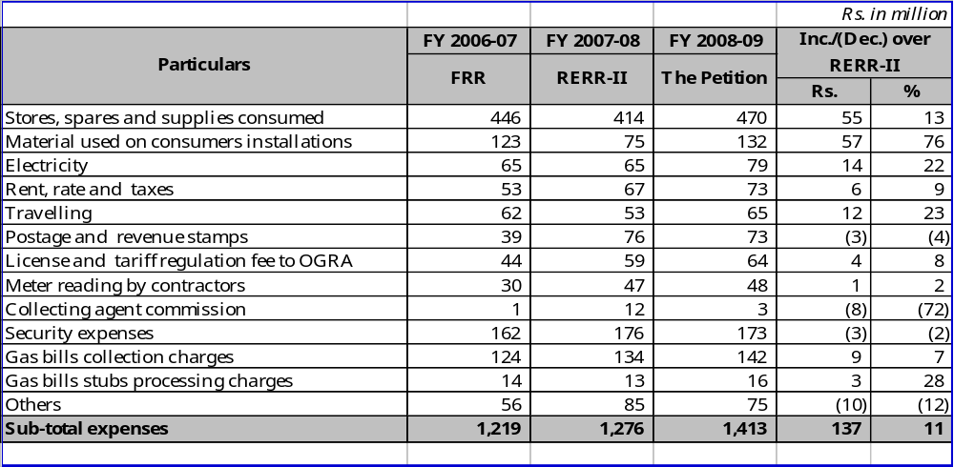

    - The Authority observes that the remaining items of T&D expense have been reasonably projected by the petitioner and therefore, provisionally accepts the same at Rs. 1,413 million.
- Transmission and Distribution Cost Determined by the Authority
    - In view of the examination in sub-para ii to xii of para 8.3 above, the Authority provisionally determines operating cost for the said year at Rs. 4,714 million as against Rs. 6,594 million claimed by the petitioner, as follows:
Table 37: Summary of T&D Cost Determined by the Authority
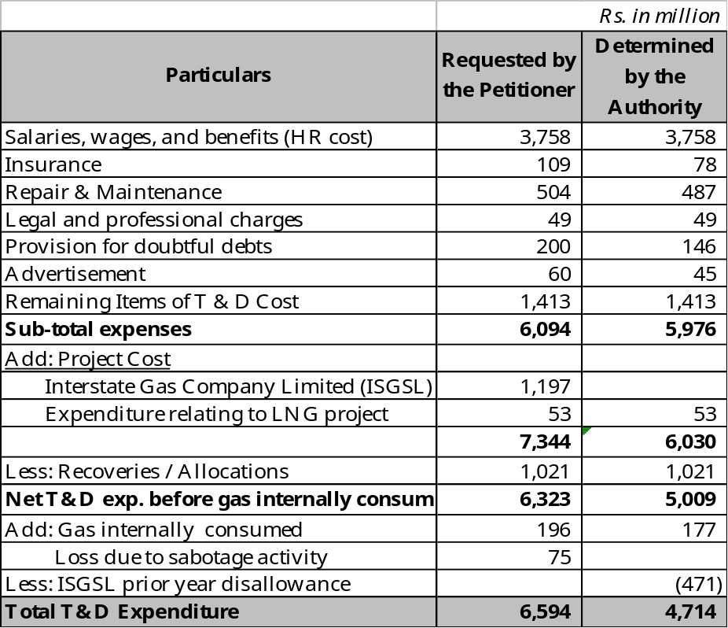
  - Government Grants
    - GoP provides grants to the petitioner for extension of distribution network in uneconomic areas that do not meet the ECC criteria, to meet its socio-economic obligations. The Authority observes that the petitioner had , on the average, been holding un-utilized funds of approximately Rs. 1.2 billion, as is evident from the following table 38:
Table 38: Closing Balances of Government Grants
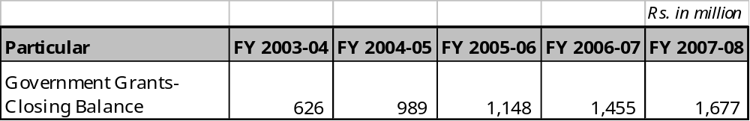
    - The petitioner through a later submission has claimed that Rs. 1.2 billion approximately of un-utilized balance did not contain adjustments for stores, stocks held for distribution and work in progress, which if included will result in negative balances during the last five years. The Authority observes that the numbers provided by the petitioner are not substantiated by detailed break up. The Authority notes that value of stores, stocks held for distribution numbers is very high and appears to be exaggerated.
    - The Authority notes that in case of SNGPL, closing balances, on the average, to the tune of Rs. 3 billion existed on a continuous basis after accounting for stocks held and work in progress.
    - The Authority, therefore, directs the petitioner to provide detailed break up of year-wise utilization of grants, duly supported by an unconditional certificate (without “exception” and/or ”subject to” provisions) from the statutory auditors as well as undertaking from the Managing Director confirming the calculations / numbers in this respect, within one month of issuance of this Order.
    - The Authority will decide this matter separately after receipt of said information.

  - Other Charges including Workers Profit Participation Fund (WPPF)

    - The petitioner has projected other charges including W.P.P.F at Rs. 274 million. However, due to adjustments in the components of revenue requirements discussed above, W.P.P.F is recalculated at Rs. 146 million and therefore, other charges are provisionally allowed at Rs. 160 million.

Decision
  - In view of the justifications submitted and arguments advanced by the petitioner in support of its petition, points raised by the interveners, comments offered by the participants, scrutiny by the Authority and detailed reasons recorded by the Authority in earlier sections, the Authority recapitulates and decides to:
    - determine the opening balance of deferred credit at Rs. 4,296 million as against Rs. 3,800 million according to the petition;
    - determine estimated addition in fixed assets at Rs. 8,912 million and depreciation charge at Rs. 2,770 million;
    - determine the balance of average net operating fixed assets (net of deferred credits) at Rs. 34,563 million as against Rs 35,466 million claimed by the petitioner for the said year. Consequently, the return required by the petitioner on its average net operating fixed assets is determined at Rs. 5,876 million;
    - determine income at Rs. 92,134 million as against Rs. 90,056 million offered by the petitioner;
    - accept the cost of gas at Rs. 102,808 million;
    - determine the UFG cut at Rs. 1,585 million per benchmark;
    - determine the T&D expenses at Rs. 4,538 million as against Rs. 5,928 million claimed by the petitioner;
    - determine the cost of GIC at Rs. 177 million as against Rs. 196 million claimed by the petitioner;
    - determine other charges including W.P.P.F. to Rs. 160 million as against Rs. 274 million claimed by the petitioner; and
  - In exercise of its powers under the Ordinance and NGT Rules, the estimated revenue requirement for the said year is determined at Rs. 114,768 million (as tabulated below), as against Rs. 117,151 million claimed by the petitioner thereby decreasing the estimated revenue requirement by Rs. 2,383 million:

Table 39: Components of ERR for FY 2008-09 as Determined by the Authority
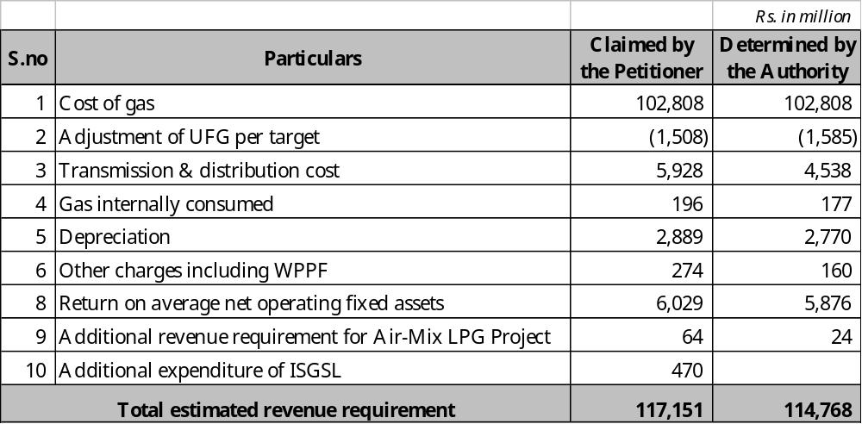
  - The provisionally allowed expenses are subject to adjustments on the basis of review under Section 8(2) of the Ordinance, and later after scrutiny of auditors’ initialed accounts of the petitioner for the said year, provided these expenses are substantiated with appropriate justification and analysis in the form acceptable to the Authority.
  - The petitioner’s net operating income is estimated at Rs. 92,134 million, as against the revenue requirement of Rs. 114,768 million and thus there is a shortfall of Rs. 22,634 million in its estimated revenue requirement for the said year. In order to adjust this shortfall, the Authority hereby makes upward adjustment of 28% (Rs. 58.97 per MMBTU) on provisional basis in its average prescribed price for the said year (Annexure-A).
  - Increase in the prices is determined at 31% in the case of domestic tariff to keep it uniform with Sui Northern Gas Pipelines Limited and at 28% in remaining categories of consumers except feed-stock gas supply to the fertilizer consumer, who is governed by separate GoP policy.
  - The Authority considers it important and essential to impress upon the petitioner that this provisional determination of estimated revenue requirement for the said year, pre-supposes that the petitioner would, in any case, faithfully and with responsibility conduct its affairs in full compliance of the requirement of Rule17(1)(h) & Rule 17(1)(j) of the NGT Rules, 2002, as reproduced below:
Rule 17(1)(h)
“tariffs should generally be determined taking into account a rate of return as provided in the license, prudent operation and maintenance costs, depreciation, government levies and, if applicable, financial charges and cost of natural gas;”
Rule 17(1)(j)
“only such capital expenditure should be included in the rate base as is prudent, cost effective and economically efficient;”
  - Provisional prescribed prices for each category of consumers for the said year, effective from July 1, 2008, are attached as Annexure-B. Increase of 28% (Rs. 58.97 per MMBTU) in the petitioner’s average prescribed prices has been adjusted in all categories of consumers excluding fertilizer-feed. Comparison between existing sales prices and revised prescribed prices is attached at Annexure-C. The prescribed prices for various categories of retail consumers determined by the Authority on provisional basis shall be subject to adjustment upon receipt of Federal Government advice under Section 8(3) of the Ordinance, in respect of the sale price of gas for each category of retail consumers provided that the overall increase in the average prescribed price remains unchanged so that the petitioner is able to achieve its total revenue requirements in accordance with Section 8(6)(f) of the Ordinance.

Directions
  - In addition to the directions issued by the Authority in its previous determinations, the petitioner is further directed to:-
    - ensure prudence and ring fencing of all capital and revenue expenditures, including all cost allocations in respect of each Air-Mix LPG, CNG or LNG based pipeline distribution projects.
    - submit a review petition to the Authority latest by October 15, 2008 for review of its estimated revenue requirements as required under Section 8(2) of the Ordinance, keeping in view the actual and anticipated changes in international prices of crude and fuel oil during the period June to November, 2008 and the trend of Rupee – Dollar exchange rate.
    - provide at the time of FRR, an unconditional (without “exception”, “subject to” provisions) certificate by its statutory auditors to the effect that HR cost used for comparison with HR benchmark, includes all regular, all contractual and casual staff / labour.
    - provide detailed break up of year-wise utilization of grants, duly supported by an unconditional certificate (without “exception” and/or ”subject to” provisions) from the statutory auditors as well as undertaking from the Managing Director confirming the calculations / numbers submitted in this respect within one month of issuance of this Order.

Public Critique, Views, Concerns, Suggestions
  - The Authority has recorded critique, views, concerns and suggestions of the interveners and participants in para 3 above, including policy issues falling within the purview of the Federal Government. The Authority considers it important to draw specific attention of the Federal Government to the same for due consideration while taking decisions about categorization of consumers, tariff structure, subsidies, GDS and sale prices for various categories of consumers.

(Syed Hadi Hasnain)  Member (Gas) |  | (M.H. Asif)  Member (Finance) |  | (Rashid Farooq)  Member (Oil) /  Vice Chairman
(Munir Ahmad)
Chairman
Islamabad.
the May 20, 2008

A: Computation of Estimated Revenue Requirement for FY 2008-09
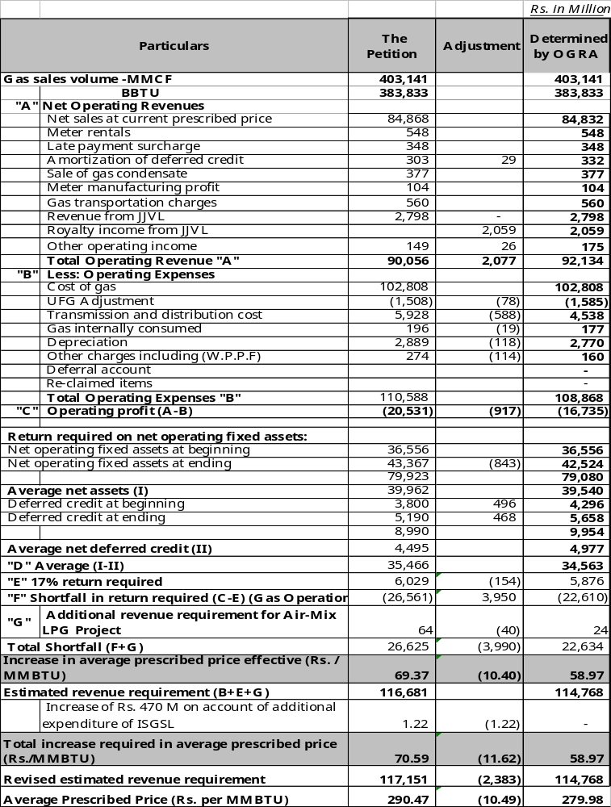

B: Provisional Prescribed Prices for FY 2008-09 w.e.f. July 1, 2008
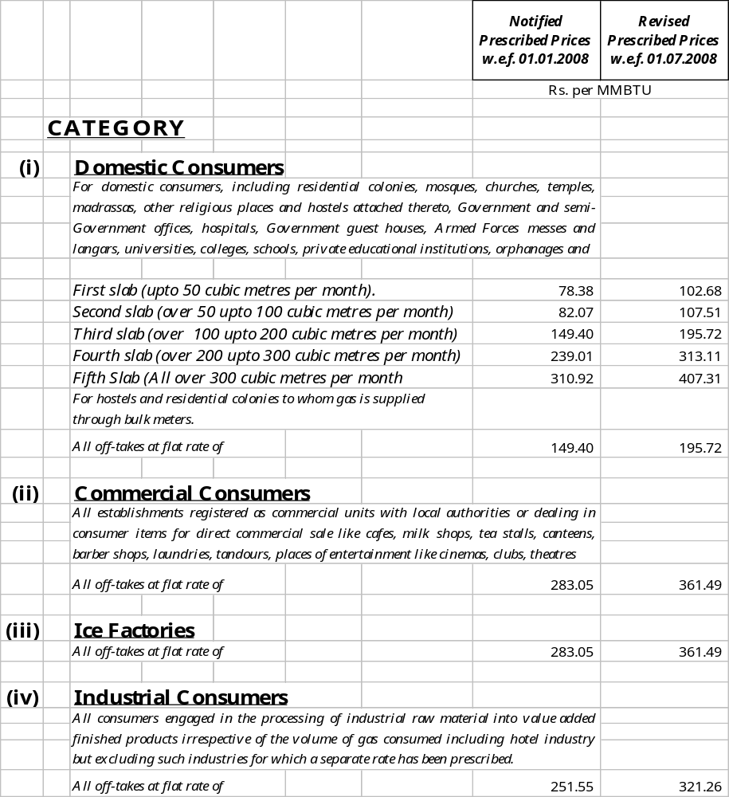
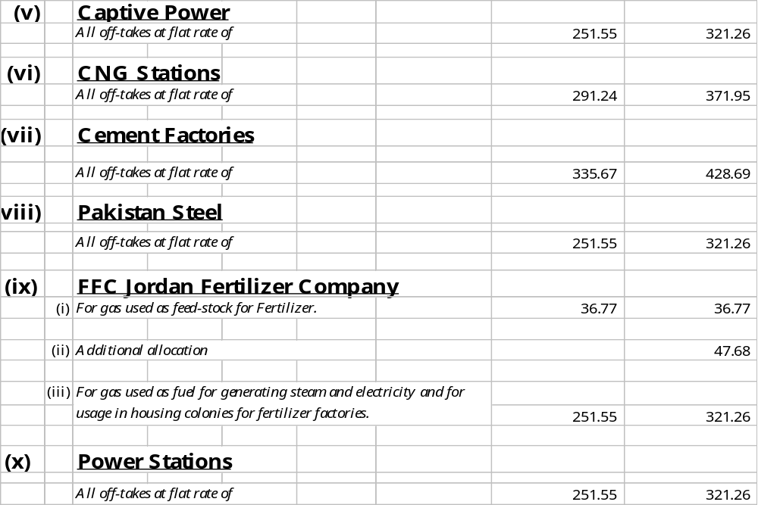

C: Comparison between Existing Sale Prices and Revised Prescribed Prices

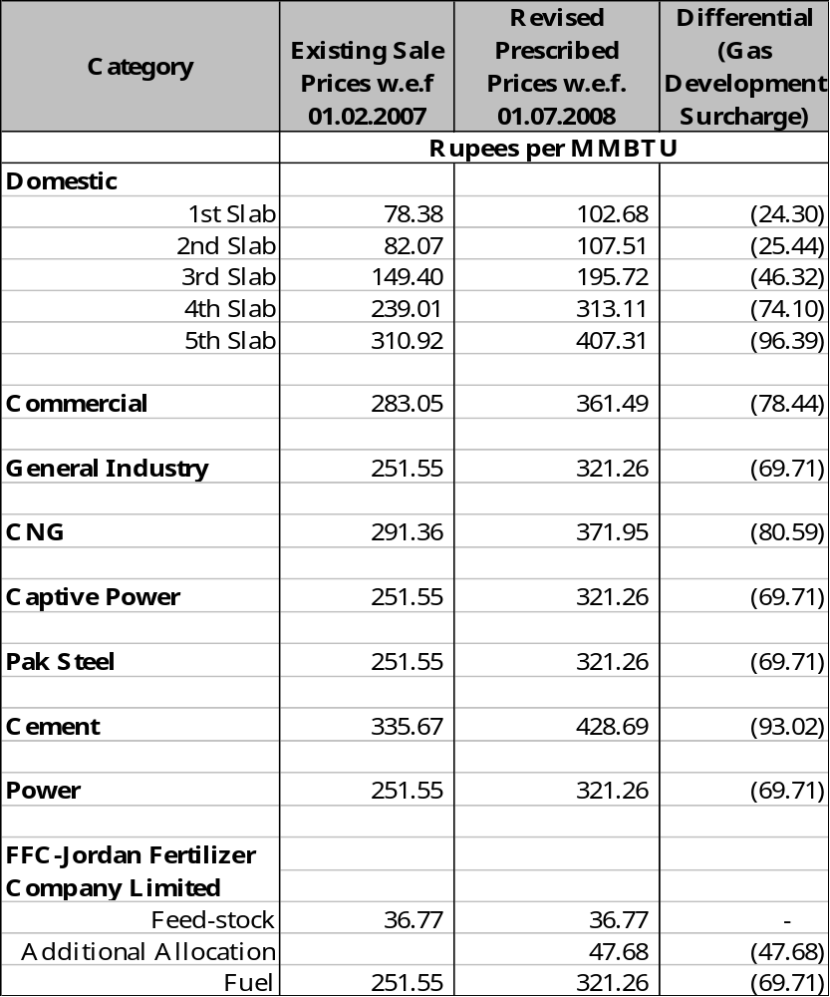

D: Detail of Addition to Rate Base Requested by the Petitioner for FY 2008-09
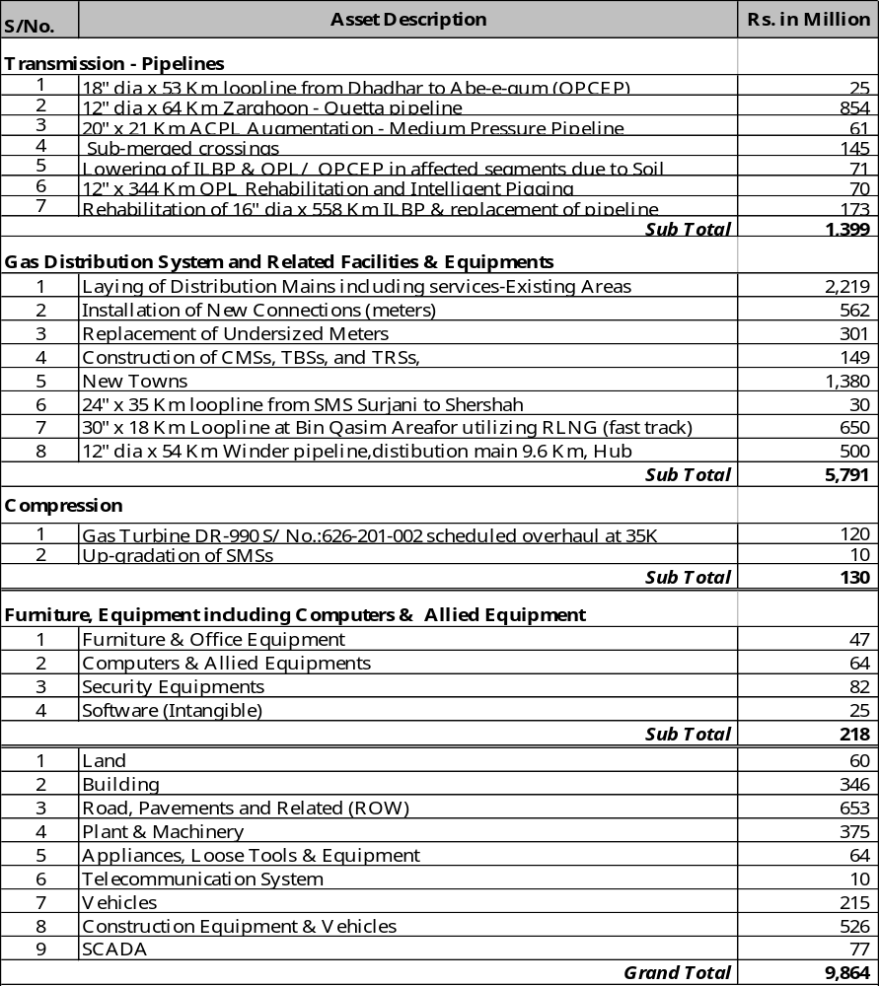

E: Computation of Weighted Average Cost of Gas



