Case No. OGRA-6(2)-1(2)/2007-Review

IN THE MATTER OF

SUI NORTHERN GAS PIPELINES LIMITED
REVIEW OF ESTIMATED REVENUE REQUIREMENT, FY 2007-08

UNDER

SECTION 8(2) OF THE OIL AND GAS REGULATORY AUTHORITY ORDINANCE, 2002 AND
NATURAL GAS TARIFF RULES, 2002

DECISION

January 03, 2008

Before:

Munir Ahmad, Chairman
Rashid Farooq, Member Oil / Vice Chairman
M.H. Asif, Member Finance
Syed Hadi Hasnain, Member Gas

Table of Contents

1. BACKGROUND - 1 -
2. PROCEEDINGS - 3 -
3. INTERVENERS’ VIEWS - 4 -
4. PETITIONER’S RESPONSE TO THE VIEWS OF INTERVENERS - 5 -
5. COST OF GAS - 5 -
6. UFG ADJUSTMENT - 8 -
7. DETERMINATION - 8 -

Tables
Table 1: Component-wise Breakup of Requested Increase in Average Prescribed Price - 2 -
Table 2: Comparative Analysis of Average Prices of Crude Oil & HSFO - 7 -

- BACKGROUND
  - Sui Northern Gas Pipelines Limited (the petitioner) is a public limited company, incorporated in Pakistan, and listed on the Karachi, Lahore and Islamabad Stock Exchanges. It is engaged in the business of construction and operation of gas transmission & distribution pipelines and sale of natural gas.
  - The Authority had determined the Estimated Revenue Requirement (ERR) of the petitioner for FY 2007-08 (the said year) at Rs. 123,550 million vide its order dated May 21, 2007 under Section 8(1) of the Oil and Gas Regulatory Authority Ordinance, 2002 (the Ordinance).
  - The petitioner submitted this review petition (the petition) on October 31, 2007, under Section 8(2) of the Ordinance, incorporating the upward change in the projected Weighted Average Cost of Gas (WACOG) during the said year based on the increasing actual oil prices in the international market and projected gas purchase volume taking into account actual gas supplies / purchases during the first quarter, July - September 2007 as well as other latest indications. The petitioner projected shortfall in the determined ERR of Rs. 3,993 million, and sought immediate relief pursuant to Rule 5(7) of Natural Gas Tariff Rules, 2002 (NGT Rules, 2002).
  - The petitioner submitted that WACOG was projected to rise to Rs. 181.04 per MMBTU as against Rs. 176.02 per MMBTU projected while determining the ERR for the said year in May, 2007. This situation has arisen due to sharp and persistent increase in average crude oil and High Sulphur Fuel Oil (HSFO) prices in the international market during June – November 2007, which period was required to be used as the basis for determining the well-head prices in terms of Gas Pricing Agreements (GPAs) between the Government of Pakistan and various gas producers.
  - The petitioner sought immediate relief to cover the aforesaid estimated shortfall of Rs. 3,993 million during the said year through increase in average prescribed price by Rs. 14.20 per MMBTU, effective January 01, 2008, as sale prices could not possibly be increased on retroactive basis. The petitioner gave component-wise breakup of requested increase in average prescribed price as under:
Table 1: Component-wise Breakup of Requested Increase in Average Prescribed Price
 |  | Rs. / MMBTU
A: | Increase in operating revenue due to revised estimated sale volume and sale mix |  | 1.90
B: | Increase in Cost of Gas Sold
 | Increase in WACOG | 5.02
 | Increase due to Volume Variance | 3.75 | 8.77
C: | Increase in Gas Internally Consumed |  | 0.15
(B+C)-A | Net Increase w.e.f July 01, 2007 in Cost of Gas Sold |  | 7.02
 | Increase requested in average prescribed prices w.e.f January 01, 2008 |  | 14.20

  - The Authority, after preliminary examination, noted that increase in the prescribed prices as a consequence of increase in cost of gas was inescapable and, therefore, passed an Interim Order, No. OGRA-6(2)-1(2)/2007-Review on November 20, 2007, increasing the average prescribed price by Rs. 13.77 per MMBTU w.e.f January 01, 2008, after adjusting Rs. 120 million on account of higher UFG projection by the petitioner as compared to the target fixed by the Authority for the said year, and consequential adjustment of W.P.P.F of Rs. 6 million. The revised prescribed prices for various categories of retail consumers effective January 01, 2008 were then communicated to the Federal Government, in pursuance of Section 8(2) of the Ordinance, for advice on the sale prices and minimum charges within 40 days, in terms of Section 8(3) thereof. This advice was received on January 01, 2008 from the Federal Government vide letter No. DGO(AC)-5(26)/07 dated January 01, 2008 (Annexure-I), and the revised sale prices along with minimum charges for various categories of consumers were notified by the Authority on the same day (Annexure-II).
  - A notice inviting interventions / comments from the consumers, general public and other interested / affected persons, and intimating the time and place of the public hearing, was published in daily newspapers, namely: Daily Dawn, Daily Express, Nawa-i-waqt (combined) and Mashriq (Peshawer) on November 21, 2007. The Authority received three applications to intervene in the proceedings from the following persons/entities:
- Sarhad Chamber of Commerce & Industry.
- Mahmood Elahi Engineer, Faisalabad.
- Sikandar-e-Azam & Sons, Sheikhupura.
  - The Authority admitted all the above intervention requests.

- PROCEEDINGS
  - The Authority held public hearing at Islamabad on December 10, 2007, which was attended by the following:
- SNGPL team led by Mr. Amir Tufail, Chief Financial Officer - Petitioner
- Mr. Mahmood Elahi, Sui Gas Contractor, Faisalabad - Intervener
- Mr. Sikandar-e-Azam, Sui Gas Contractor, Sheikhupura - Intervener
  - The Sarhad Chamber of Commerce & Industry was not represented. However its written representation has been received.
  - The petitioner made submissions in detail with the help of multimedia presentation explaining the basis of the petition for increase in prescribed prices of gas on account of increased wellhead prices.

- INTERVENERS’ VIEWS
  - The substantive points made by the interveners are summarized below:
i) Natural gas is an indigenous fuel and is adequately available in the country. The gas prices, therefore, should not be linked with the international prices of crude oil and HSFO; rather they should be at par with the prices in oil/gas rich countries.
ii) Government should undertake necessary measures to reduce the consumer gas prices as they are much higher compared to the prices prevailing in the neighboring countries.
iii) The policy for involving houseline contractors has been revised by the petitioner, which has resulted in corruption and compromise on quality, thereby increasing line losses and operating cost of the company.
iv) Delay in providing connections to the consumers has resulted in revenue loss to the company thereby increasing the consumer prices. Further, the natural gas pressure requirements are not taken into account while laying new transmission and distribution lines, which leads to leakages and pressure drops.
v) Recruitment is not carried out in transparent manner and there is rampant favoritism, which too results in operational inefficiency and higher UFG.
- PETITIONER’S RESPONSE TO THE VIEWS OF INTERVENERS
  - The petitioner has argued that the petition relates to the change in cost of gas due to anticipated change in wellhead gas prices for the period January – June 2008 and has briefly explained the procedure of fixation of wellhead gas prices, which are linked to the international prices of crude oil /HSFO.
  - The petitioner has further argued that:
  - It is not correct that gas is available locally in abundance. In fact, it is far less than the actual and potential demand.
  - Other matters raised by the interveners are not related to the present petition. However, the reason for change in policy relating to the houseline contractors was large number of complaints of irregularities against them.
The petitioner has, however, offered to meet the interveners to discuss their complaints and address them as far as possible. The Authority advised the interveners to contact the petitioner for the proposed meeting, and in the event of being aggrieved of the petitioners decision could file a complaint with the Registrar of the Authority under OGRA Complaint Resolution Procedure Regulations, 2003.
- COST OF GAS
  - Petitioners Grounds for Review
    - The petitioner has claimed estimated shortfall of Rs. 3,993 million on account of increase in the cost of gas and revised projection of gas purchases taking into account actual gas supplies during the first quarter of the said year i.e July - September, 2007.
    - The petitioner has submitted that as against Rs. 176.02 per MMBTU, projected at the time of determination of ERR for the said year, the WACOG is projected to increase to Rs. 181.04 per MMBTU on an annualized basis.
    - The petitioner has re-worked the WACOG using the following parameters:
- Well-head gas prices of various producing fields for the period July 1, 2007 to December 31, 2007, as already notified by the Authority.
- The prices of crude oil and HSFO during the period June, 2007 to November, 2007 to form the basis for computing well-head prices for the period January 1, 2008 to June 30, 2008 as provided in the existing GPAs between the Government of Pakistan and various gas producers.
- Actual prices of crude oil & HSFO for the period June, 2007 to October, 2007 and average crude oil & HSFO prices for November, 2007, assumed at US $ 84.22 per barrel and US $ 480.97 per ton respectively keeping in view the persistent increasing trend.
- US $ exchange rate assumed at Rs. 60.85 during January to June 2008.
    - On the basis of the above parameters, the petitioner has estimated average C & F prices of crude oil and HSFO for June-November, 2007 at US $ 74.30 per barrel and US $ 399.40 per ton respectively, and has used them for computation of well-head prices for January-June, 2008.
  - Discussion and Decision
    - The Authority has carefully considered all the submissions and arguments of the parties made in writing and at the public hearing.
    - The petitioner has filed the petition under Section 8(2) of the Ordinance, under which only adjustments on account of actual changes in the well-head gas prices and relevant factors (i.e. gas purchases and sales) can be sought. Therefore, the issues other than those related to the cost of gas can not be entertained in these proceedings and this order has to be confined to the effect of change in cost of gas..
    - The Authority observes that the well-head prices of gas for all fields in Pakistan are computed in accordance with GPAs, available on record, and are notified in exercise of the powers vested in it under the Ordinance.
    - The Authority notes that average prices of crude oil and HSFO have gone up as under:

Table 2: Comparative Analysis of Average Prices of Crude Oil & HSFO
Sr. No. | Particulars | Period from December 06 to May 07¹ | Period from June 07 to Nov 07² | %age increase
(i) | Crude Oil (US $per BBL) | 60.16 | 74.30 | 24%
(ii) | HSFO (US $ per ton) | 300.24 | 399.40 | 33%
(iii) | US $ exchange rate (Rs.) | 60.40 | 60.85 | 1%
Basis of wellhead prices for July-December 2007
² Basis of wellhead prices for January-June 2008

    - The Authority finds that on the basis of currently available information, the revised projections of sale and purchase volume, and computation of cost of gas submitted by the petitioner are reasonable..
- UFG ADJUSTMENT
  - The Authority, while determining the ERR for the said year, had fixed the UFG upper & lower targets at 6% & 5.10% respectively, with the condition that the petitioner would: (i) retain the savings in the event of performance being better than the lower target, (ii) fully bear the loss for UFG above the upper target from its own profits, and (iii) absorb 50% of the loss on account of UFG between the lower and upper target if the final UFG percentage is within these two limits, while the remaining 50% would be adjusted in the revenue requirement.
  - The Authority observes that the petitioner has projected UFG at 5.32%, which is 0.22% higher than the fixed lower target and, therefore provisionally deducts Rs. 119 million and consequential adjustment of W.P.P.F thereon of Rs. 6 million, from the revenue requirement of the petitioner, being the correct 50% share, as against Rs. 5 million disallowance incorrectly calculated by the petitioner.

- DETERMINATION
  - The Authority, after taking into consideration the points raised by the interveners, the clarifications provided by the petitioner, scrutiny of the petition and available record, provisionally determines the shortfall in the estimated revenue requirement for the said year at Rs. 3,872 million, as against Rs. 3,993 million claimed by the petitioner and since sale prices cannot be increased retroactively, decides to recover it in the remaining six months, i.e. January - June, 2008
  - The Authority, therefore, in exercise of its powers under Rule 5 (7) of the NGT Rules, 2002, confirms its Interim Order, dated November 20, 2007, allowing an increase of Rs. 13.77 per MMBTU (Annexure-III) in the average prescribed price of the petitioner on provisional basis w.e.f. January 01, 2008 to enable it to recover the estimated shortfall of Rs. 3,872 million in its ERR for FY 2007-08.
  - According to para 3.4 of its aforesaid Interim Order, of November 20, 2007, the revised provisional prescribed prices were determined by the Authority on provisional basis subject to the following condition:
“The price for each category of retail consumers may be re-adjusted upon receipt of Federal Government advice under Section 8 (3) of the Ordinance in respect of the sale price of gas for each category of retail consumers provided that the overall increase in the average prescribed price remains unchanged so that the petitioner is able to achieve its total revenue requirements in accordance with Section 8 (6) (f) of the Ordinance.”
  - Pursuant to the advice of the Federal Government, the Authority hereby re-adjusts the prescribed prices of the petitioner in such a manner that the prescribed prices of each category of retail consumers remains equal to or less than the sale price as advised by the Federal Government for that category of consumers. The revised prescribed prices of the petitioner, effective January 01, 2008, are determined accordingly, on provisional basis as at Annexure-IV.

(Syed Hadi Hasnain)  Member (Gas) |  | (M.H. Asif)  Member (Finance) |  | (Rashid Farooq)  Member (Oil) /  Vice Chairman
(Munir Ahmad)
Chairman
Islamabad,
January 3, 2008
COPY OF ADVICE FROM THE FEDERAL GOVERNMENT REGARDING REVISED CONSUMER SALE PRICES & MINIMUM CHARGES W.E.F JANUARY, 01, 2008.

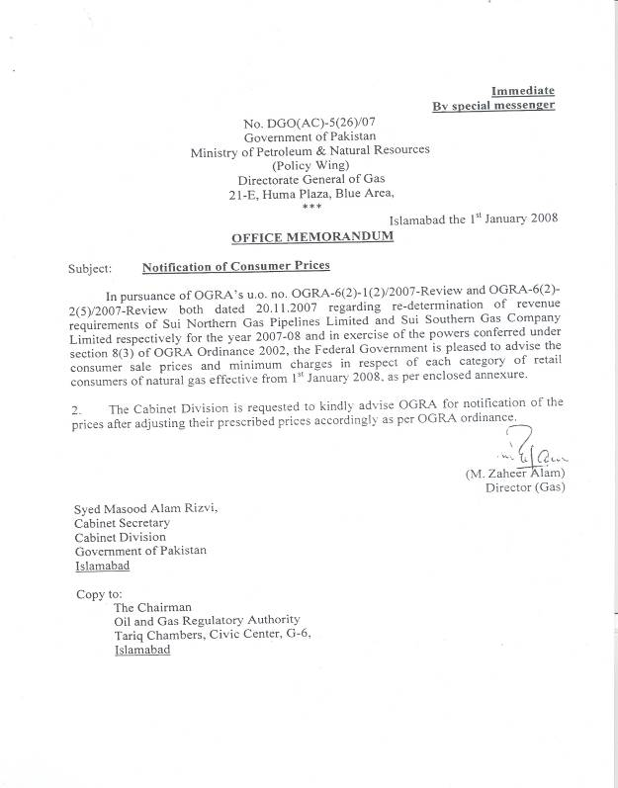

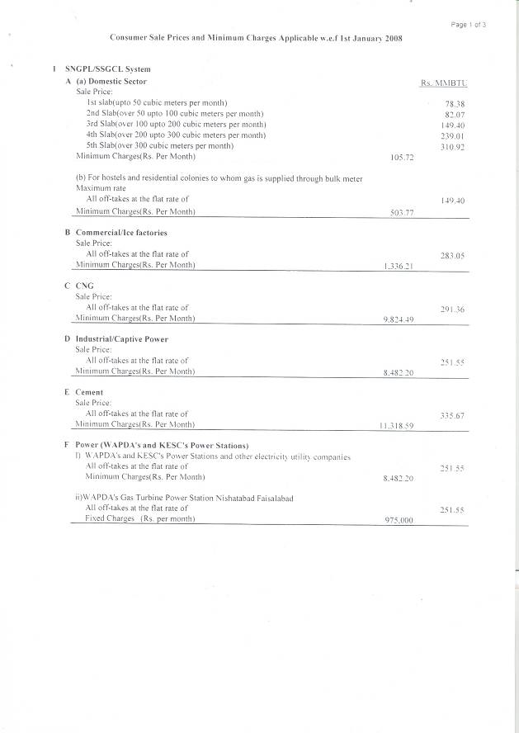

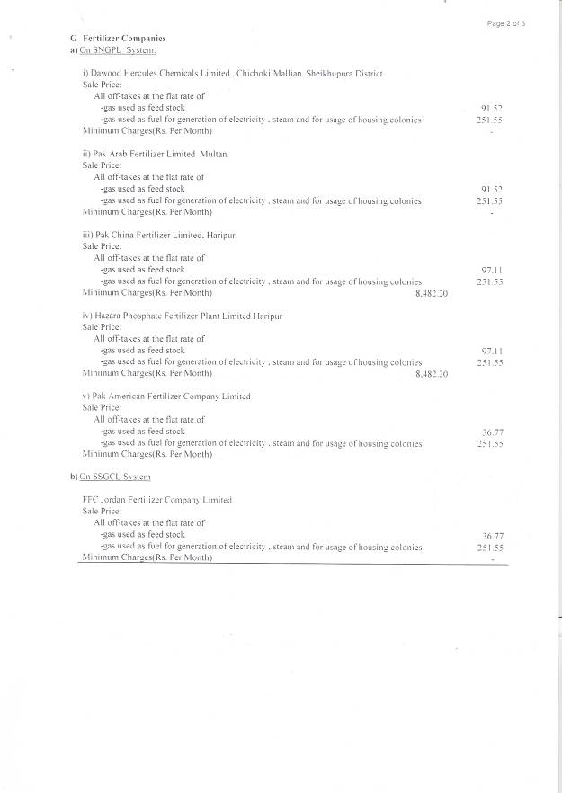

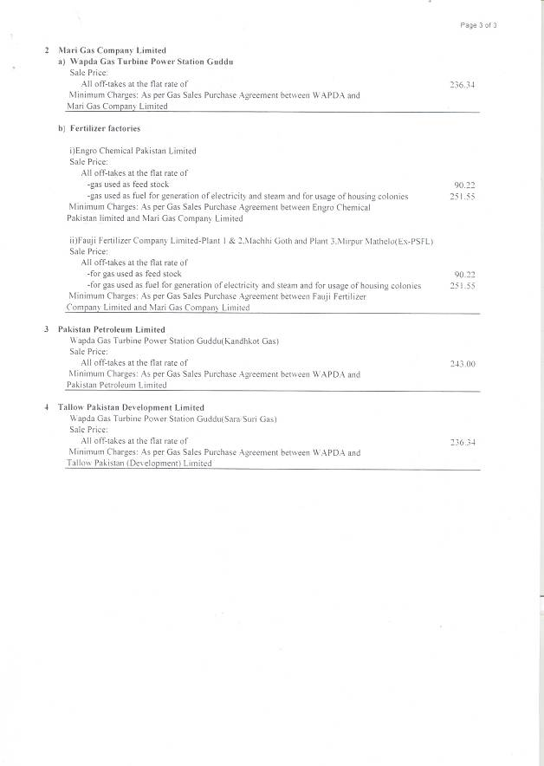
NOTIFICATION OF SALE PRICES & MINIMUM CHARGES FOR EACH CATEGORY OF CONSUMERS W.E.F JANUARY 01, 2008



